**A PROJECT REPORT ON**

XXXXX **Library Managing System** XXXXX

**Submitted to XXXXXX University for the partial fulfillment of the   
requirement for the**

**Award of Degree for**

XXXXXXXXXXX **Course Name** XXXXXXXXXXXXX

**Done By**

# Mr. / Miss. XXXXXX

## XXXXX Institute of Management & Computer Sciences

**Hyderabad**

**CERTIFICATE**

This is to certify that Mr. / Miss XXXXXXXXXX, bearing Roll No. XXXXXXXXXXX have developed Software Project Titled XXXXXXXXXXXXXX for XXXXXXXXX **SOFTWARE SOLUTIONS** as a partial Fulfillment for the award of the Degree of XXXXXXXXXXXXXX.

**HEAD OF DEPARTMENT** **PRINCIPAL**

**XXX institute of Management**

**&**

**Computer Sciences**

**EXTERNAL**

#### ACKNOWLEDGMENT

My express thanks and gratitude and thanks to Almighty God, my parents and other family members and friends without whose uncontained support, I could not have made this career in XXXXXXXXXX.

I wish to place on my record my deep sense of gratitude to my project guide, **Mr. / Miss XXXXXXXXXX, XXXXX Software Solutions, Hyderabad** for his/her constant motivation and valuable help through the project work. Express my gratitude to **Mr. / Miss XXXXXXXXX**, Director of XXXXXXXXX **Institute of Management & Computer Sciences** for his/her valuable suggestions and advices throughout the XXXXXXXX course. I also extend my thanks to other Faculties for their Cooperation during my Course.

Finally I would like to thank my friends for their cooperation to complete this project.

XXXXXXXXXXXX

(XXXXXX)

##### **ABSTRACT**

Library Managing System is a web based application the main theme of the application storing the details about the books in a library and their count and searching to gain one idea about the libraries books and we can also search categories wise books and book names and also administrator can issue books return books and add publisher ,add suppliers ,add categories .This is a tool to mange library books , where we can create one setup file by using that any user can install it onto their system and can use all the options provided by Library management tool. This will reduce the burden on users who will maintain all records manually. Generally library management is the most complex thing as it involves a great deal of database with in that. Managing Books in category wise allocating books to users is done by manual process, computerization of this process will help to improve the performance and reduce the errors. Library Managing System is a comprehensive library management solution that is suitable for both large and small libraries. Its flexible design enables MINFO Library Managing System to be installed in a range of Library organizations, ranging from public libraries, through to academic, joint use and special libraries. One of MINFO Library Management Software's strengths is that while it has been developed using the latest software technologies (Windows based Client Server) it is also a mature, proven system.

##### 

**CONTENTS**

1. **INTRODUCTION**
   1. INTRODUCTION TO PROJECT
   2. ORGANIZATION PROFILE
   3. PURPOSE OF THE PROJECT
2. **SYSTEM ANALYSIS**
   1. INTRODUCTION
   2. ANALYSIS MODEL
   3. STUDY OF THE SYSTEM
   4. HARDWARE & SOFTWARE SPECIFICATIONS
   5. PROBLEMS IN EXISTING STSTEM
   6. SOLUTION OF THESE PROBLEMS IN PROPOSED SYSTEM
   7. INPUT & OUTPUT
3. **FEASIBILITY REPORT**
   1. TECHNICAL FEASIBILITY
   2. OPERATIONAL FEASIBILITY
   3. ECONOMIC FEASIBILITY
4. **SOFTWARE REQUIREMENT SPECIFICATIONS**
   1. FUNCIONAL REQUIREMENTS
   2. NON-FUNCIONAL REQUIREMENTS
   3. PERFORMANCE REQUIREMENTS
5. **SYSTEM DEVELOPEMENT ENVIRONMENT**
   1. INTRODUCTION TO .NET FRAMEWORK
   2. ASP.NET
   3. C#.NET
   4. SQL SERVER
6. **SYSTEM DESIGN**

6.1. INTRODUCTION

6.2. NORMALIZATION

6.3. DATA DICTIONARY

6.4. E-R DIAGRAM

6.5. DATA FLOW DIAGRAM

6.6. ACTIVITY DIAGRAM

6.7. USE CASE DIAGRAM

6.8. SEQUENCE DIAGRAM

6.9. CLASS DIAGRAM

6.10. COLLOBORATION DIAGRAM

1. **OUTPUT SCREENS**
2. **SYSTEM TESTING AND IMPLEMENTATION** 
   1. INTRODUCTION
   2. STRATEGIC APPROACH OF SOFTWARE TESTING
   3. TESTING STRATEGIES
   4. TEST CASES
3. **SYSTEM SECURITY**

9.1. INTRODUCTION

* 1. SECURITY IN SOFTWARE

1. **CONCLUSION**
2. **FUTURE ENHANCEMENT**
3. **BIBLIOGRAPHY**

**Chapter 1**

**INTRODUCTION**

**1.1. INTRODUCTION TO PROJECT**

Library Managing System is a web based application the main theme of the application storing the details about the books in a library and their count and searching to gain one idea about the libraries books and we can also search categories wise books and book names and also administrator can issue books return books and add publisher ,add suppliers ,add categories .Library Managing System is a comprehensive library management solution that is suitable for both large and small libraries. Its flexible design enables MINFO Library Managing System to be installed in a range of Library organizations, ranging from public libraries, through to academic, joint use and special libraries. One of MINFO Library Management Software's strengths is that while it has been developed using the latest software technologies (Windows based Client Server) it is also a mature, proven system. For every Library Managing System is below process for a receipt and issuance of books in the library along with the user’s details. For every Library Managing System is below process for a receipt and issuance of books in the library along with the user’s details. The books received in the library are entered in Books Entry form and the new user is entered in the user entry form. When the user wants to get the desired book the same is issued on the availability basis to the user

* 1. **ORGANIZATION PROFILE**

###### Datapoint Info Solutions (P) Ltd logo

S i m p l i f y i n g S o l u t I o n s & O p p o r t u n i t i e s

# Business Proposition

**Datapoint** is incepted by young and ambitious team of Professional in the Industry with the Idea & motto of ***“Simplifying Solutions & opportunities”***. Datapoint is into IT Training (Corporate/Individual), Project assistance, Software Development and Placements. Datapoint is one among the very few companies in Hyderabad, which are spread across all the areas and technologies.

**Datapoint has been actively in the profession of sourcing IT professionals from the year 2001.** We have since placed scores of candidates from different skill sets, with varying levels of experience.

Datapoint started its journey initially as a Consulting Company and as a successful Placement Consultants as per the clients requirements we also emerged as a Corporate Training. Of-late we found that many engineering graduates are not being able to find jobs for themselves, despite increasing demand for IT professionals & Even our clients couldn’t able to find the suitable and potential candidates even in the freshers.

At this crucial point we found the gap which needed to be filled by Datapoint to improve our client satisfaction levels. The very decision of ***“Training (IT & Non-IT aspects) & providing Project assistance”*** to the freshers made Datapoint as a significant player in the market. Datapoint is assisting many colleges and Organizations in Training & Recruiting freshers.

At Datapoint, unlike other training institutes we know the Industry requisites and what an Organization expects from a candidate and henceforth we train our users accordingly so that they can get in to the market with more confidence. Datapoint as we already mentioned not only trains extensively on technologies but also on soft skills. **Datapoint also motivates the users to implement the projects on their own, which gives them a real time exposure towards the same.**

**Datapoint endeavors to be a pioneer in Recruiting and manpower consulting** thanks to strategic alliances with leading multinational companies in India and US of America. **Our technically competent, experienced, and certified consultants will help our clientele to get the right manpower at the right time.** We take pride in having top-notch companies who make enable us to have faith in the future through maintaining high quality in screening, hiring and management.

Datapoint has identified a number of areas of thrust in the emerging and ever growing IT industry and virtue of which, we would focus all our energies to get on to the fast track in the shortest possible period. We pursue requirements from leading Corporate in India and abroad.



## Mission

“Our mission is to identify, recruit and facilitate quality manpower who are technically strong, dynamic and determined, as we are, for the future belongs to those who think and prove global.”

# Why choose Datapoint for Academic Projects?

Our Project training is based on industry expectations and we will allow the users to do project in real time environment under the guidance of industrial experts. We afford quality training to user which is evinced by the fact that several colleges recommended their users for our extensive project training

# Why choose Datapoint for Placements?

We guarantee **reliable and productive candidates**, which is evinced by the fact that over **94% of our clientele** have done repeat businesses with us. We provide candidates at competitive bill rates, guaranteed not to change during the life of your assignment.

Once your positions are filled, they are there to stay.

**“Simplifying Opportunities”:** It’s more than just our slogan. Our entire business is geared toward helping our clients to successfully complete and implement their critical I.T initiatives in a timely and cost efficient manner. Our job is to provide you with “Excellent manpower which makes the organization” so that you can be more successful and continue to be the leader in the industry.

### SERVICES

The Company has identified the following as thrust areas:

* IT Solutions
* Training (On and Off Campus)
* Academic Project Assistance (All branches)
* Conducting Events (For Our Clients)
* Placement Services
* Outsourcing of Manpower

**For More Details please reach us:**

**Suresh Maguluri – Managing Director,**

**Datapoint Info Solutions (P) Ltd,**

**Call: 040 – 64618648 / 64518649 / 98497 53709.**



**Why**?????

* Established in 2001.
* An ISO 9001:2000 Certified Company.
* 8 Years of Expertise in Recruitments & Staffing.
* Having Own Software Development Division.
* Had a Clientele of about 50 MNCs.
* A unique company which provides opportunities to freshers.
* The Company, which helps you to meet the Industry expectations.
* Excellent track record in placing the Candidates of various levels.
* A company with the Coding standards of CMM level companies’.
  1. **PURPOSE OF THE PROJECT**

The purpose of this Project documents is to help the project. It is provided with some details which are used in **Library Managing System**. All parts; design, coding and testing will be prepared with helping of documents. Library Managing System is a comprehensive library management solution that is suitable for both large and small libraries. Its flexible design enables MINFO Library Managing System to be installed in a range of Library organizations, ranging from public libraries, through to academic, joint use and special libraries.. One of MINFO Library Management Software's strengths is that while it has been developed using the latest software technologies (Windows based Client Server) it is also a mature, proven system. For every Library Managing System is below process for a receipt and issuance of books in the library along with the user’s details.

**Chapter 2**

**SYSTEM ANALYSIS**

**2.1. INTRODUCTION**

After analyzing the requirements of the task to be performed, the next step is to analyze the problem and understand its context. The first activity in the phase is studying the existing system and other is to understand the requirements and domain of the new system. Both the activities are equally important, but the first activity serves as a basis of giving the functional specifications and then successful design of the proposed system. Understanding the properties and requirements of a new system is more difficult and requires creative thinking and understanding of existing running system is also difficult, improper understanding of present system can lead diversion from solution.

**2.2. ANALYSIS MODEL**

This document play a vital role in the development of life cycle (SDLC) as it describes the complete requirement of the system. It means for use by developers and will be the basic during testing phase. Any changes made to the requirements in the future will have to go through formal change approval process.

SPIRAL MODEL was defined by Barry Boehm in his 1988 article, “A spiral Model of Software Development and Enhancement. This model was not the first model to discuss iterative development, but it was the first model to explain why the iteration models.

As originally envisioned, the iterations were typically 6 months to 2 years long. Each phase starts with a design goal and ends with a client reviewing the progress thus far. Analysis and engineering efforts are applied at each phase of the project, with an eye toward the end goal of the project.

The steps for Spiral Model can be generalized as follows:

* The new system requirements are defined in as much details as possible. This usually involves interviewing a number of users representing all the external or internal users and other aspects of the existing system.
* A preliminary design is created for the new system.
* A first prototype of the new system is constructed from the preliminary design. This is usually a scaled-down system, and represents an approximation of the characteristics of the final product.
* A second prototype is evolved by a fourfold procedure:

1. Evaluating the first prototype in terms of its strengths, weakness, and risks.
2. Defining the requirements of the second prototype.
3. Planning a designing the second prototype.
4. Constructing and testing the second prototype.

* At the customer option, the entire project can be aborted if the risk is deemed too great. Risk factors might involve development cost overruns, operating-cost miscalculation, or any other factor that could, in the customer’s judgment, result in a less-than-satisfactory final product.
* The existing prototype is evaluated in the same manner as was the previous prototype, and if necessary, another prototype is developed from it according to the fourfold procedure outlined above.
* The preceding steps are iterated until the customer is satisfied that the refined prototype represents the final product desired.
* The final system is constructed, based on the refined prototype.
* The final system is thoroughly evaluated and tested. Routine maintenance is carried on a continuing basis to prevent large scale failures and to minimize down time.

**The following diagram shows how a spiral model acts like:**

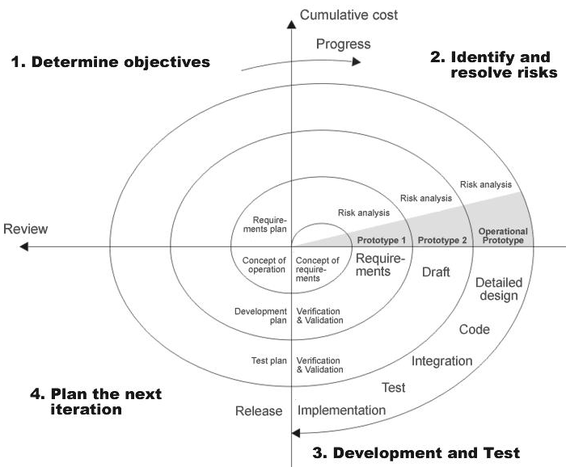

**Fig 1.0: Spiral Model**

The developer is responsible for:

* Developing the system, this meets the SRS and solving all the requirements of the system.
* Demonstrating the system and installing the system at client's location after the acceptance testing is successful.
* Submitting the required user manual describing the system interfaces to work on it and also the documents of the system.
* Conducting any user training that might be needed for using the system.
* Maintaining the system for a period of one year after installation.

**INPUT DESIGN:**

Input design is a part of overall system design. The main objective during the input design is as given below:

* To produce a cost-effective method of input.
* To achieve the highest possible level of accuracy.
* To ensure that the input is acceptable and understood by the user.

**INPUT STAGES:**

The main input stages can be listed as below:

* Data recording
* Data transcription
* Data conversion
* Data verification
* Data control
* Data transmission
* Data validation
* Data correction

**INPUT TYPES:**

It is necessary to determine the various types of inputs. Inputs can be categorized as follows:

* External inputs, which are prime inputs for the system.
* Internal inputs, which are user communications with the system.
* Operational, which are computer department’s communications to the system?
* Interactive, which are inputs entered during a dialogue.

**INPUT MEDIA:**

At this stage choice has to be made about the input media. To conclude about the input media consideration has to be given following:

* Type of input
* Flexibility of format
* Speed
* Accuracy
* Verification methods
* Rejection rates
* Ease of correction
* Storage and handling requirements
* Security
* Easy to use
* Portability

Keeping in view the above description of the input types and input media, it can be said that most of the inputs are of the form of internal and interactive. As Input data is to be the directly keyed in by the user, the keyboard can be considered to be the most suitable input device.

**OUTPUT DESIGN:**

Outputs from computer systems are required primarily to communicate the results of processing to users. They are also used to provide a permanent copy of the results for later consultation. The various types of outputs in general are:

* External Outputs, whose destination is outside the organization
* Internal Outputs whose destination is within organization and they are the
  + - User’s main interface with the computer.
* Operational outputs whose use is purely within the computer department.
* Interface outputs, which involve the user in communicating directly with

**OUTPUT DEFINITION:**

# The outputs should be defined in terms of the following points:

* + - Type of the output
    - Content of the output
    - Format of the output
    - Location of the output
    - Frequency of the output
    - Volume of the output
    - Sequence of the output

It is not always desirable to print or display data as it is held on a computer. It should be decided as which form of the output is the most suitable.

For Example:

* Will decimal points need to be inserted
* Should leading zeros be suppressed.

**OUTPUT MEDIA:**

In the next stage it is to be decided that which medium is the most appropriate for the output. The main considerations when deciding about the output media are:

* The suitability for the device to the particular application.
* The need for a hard copy.
* The response time required.
* The location of the users
* The software and hardware available.

Keeping in view the above description the project is to have outputs mainly coming under the category of internal outputs. The main outputs desired according to the requirement specification are:

The outputs were needed to be generated as a hot copy and as well as queries to be viewed on the screen. Keeping in view these outputs, the format for the output is taken from the outputs, which are currently being obtained after manual processing. The standard printer is to be used as output media for hard copies.

**2.3. STUDY OF THE SYSTEM**

In the flexibility of uses the interface has been developed a graphics concepts in mind, associated through a browser interface. The GUI’s at the top level has been categorized as follows

1. Administrative User Interface Design
2. The Operational and Generic User Interface Design

The administrative user interface concentrates on the consistent information that is practically, part of the organizational activities and which needs proper authentication for the data collection. The Interface helps the administration with all the transactional states like data insertion, data deletion, and data updating along with executive data search capabilities.

The operational and generic user interface helps the users upon the system in transactions through the existing data and required services. The operational user interface also helps the ordinary users in managing their own information helps the ordinary users in managing their own information in a customized manner as per the assisted flexibilities.

# NUMBER OF MODULES

After looking at the functional requirements it is identified that we can divide the system into mainly following modules:

* Admin Module:
* User
* User Authentication & Authorization Module

**Module Description:**

Administrator

* Adding publishers
* Adding suppliers
* Adding authors
* Searching books
* Issuing books
* Returning books
* Adding books

User

* Searching books
* Viewing status
* Change credentials

**Admin:**

In Library Managing System the administrator is mainly responsible for the adding the books and verifying the books and managing the counts of books and checking credentials and managing categories .First he can search books and details and count .He is only responsible person for managing books in a library. and he can add the publishers, suppliers, Authors and he can add the books and search the books and allot the books according to users and return the books. And user is responsible for changing credentials and searching books and viewing status of books

**User:**

In online Library Managing System user responsibility is just viewing the online books details. The main problem with previous is user for taking books he went to library and check the book details .If the book is not available then the user troubles but in this module before going to library user check the books in online whether particular book available or not .otherwise if any book is taken what is the fine for particular books all the details is known in online due to this we can save

**User Authentication & Authorization Module:**

This module contains all the information about the authenticated user. User without his/her username and password can’t enter into the login if he/she is only the authenticated user then he/she can enter to his/her login and he/she can see the all the information related to the project which he/she is developing. This module uses Form Based Authentication & Authorization to make security.

**Users of the System:**

This system should be designed to support the following users:

* Administrators
* Users

**2.4. HARDWARE & SOFTWARE SPECIFICATIONS**

**HARDWARE REQUIREMENTS:**

* PIV 2.8 GHz Processor and Above
* RAM 512MB and Above
* HDD 10 GB Hard Disk Space and Above

**SOFTWARE REQUIREMENTS:**

* WINDOWS OS (XP / 2000 / 2000 Server / 2003 Server)
* Visual Studio .Net 2008/2010 Enterprise/Professional Edition
* Internet Information Server 5.0 (IIS)
* MS.Net Framework 3.5
* SQL Server 2005/2008 Enterprise Editio

**2.5.PROBLEMS IN EXISTING STSTEM**

We have entered all the book details manually and book category information is a more importantly it is error prone. And searching books is also take long time it is very Burdon the man power searching and retrieving and mainly counting of the books. The following disadvantages due to manual system

* Searching books is also take long time it is very Burdon the man power searching and retrieving.
* It consumes lot of manpower.
* It deals with the managing books of users.
* There is no Data sharing Concept
* This process will improve the information briefly
* It lacks data security.
* Retrieval of data takes a lot of time.
* Percentage of accuracy is less.
* Reports take time to produce.

**2.6. PROPOSED SYSTEM**

Library Managing System is a comprehensive library management solution that is suitable for both large and small libraries. Its flexible design enables Library Managing System to be installed in a range of Library organizations, ranging from public libraries, through to academic, joint use and special libraries. One of MINFO Library Management Software's strengths is that while it has been developed using the latest software technologies.

* For every Library Managing System is process for a receipt and issuance of books in the library along with the user details.
* The books received in the library are entered in Books Entry form and the new user is entered in the user entry form.
* When the user wants to get the desired book the same is issued on the availability basis to the user.
* The issuance and due date for the returning of the book is also entered into the Book Issue form under third menu Book Issue.
* The main theme of our application is storing the book names .add category wise books and searching the books according to categories and details of return books and admin can also remove the books.
* The system makes the overall task much easier and flexible.
* It can be accessed over the Internet/Internet.
* There is no risk of data mismanagement at any level while the project development is under process.

**2.6. INPUT AND OUTPUT**

The major inputs and outputs and major functions of the system are follows:

**Inputs:**

* Admin enter his user id and password for login.
* User enters his user id and password for login.
* New user gives his completed personnel, address and phone details for registration.
* Administrator giving information to generate various kinds of reports.
* Administrator will assign task to employees to provide services to the customers.
* User will put a request for a new connection to the admin.

**Outputs:**

* Admin can have his own home page.
* Users enter their own home page.
* The new user’s data will be stored in the centralized database.
* New users give his completed personnel, address and phone details for registration
* Admin get the search details of different criteria.
* Customers receives the mails from system regarding next due date.
* Different kind of reports is generated by administrator.

**Chapter 3**

**Feasibility Report**

Preliminary investigation examine project feasibility, the likelihood the system will be useful to the organization. The main objective of the feasibility study is to test the Technical, Operational and Economical feasibility for adding new modules and debugging old running system. All system is feasible if they are unlimited resources and infinite time. There are aspects in the feasibility study portion of the preliminary investigation:

* Technical Feasibility
* Operation Feasibility
* Economical Feasibility

**3.1. Technical Feasibility**

The technical issue usually raised during the feasibility stage of the investigation includes the following:

* Does the necessary technology exist to do what is suggested?
* Do the proposed equipments have the technical capacity to hold the data required to use the new system?
* Will the proposed system provide adequate response to inquiries, regardless of the number or location of users?
* Can the system be upgraded if developed?
* Are there technical guarantees of accuracy, reliability, ease of access and data security?

Earlier no system existed to cater to the needs of ‘Secure Infrastructure Implementation System’. The current system developed is technically feasible. It is a web based user interface for audit workflow at ABC Tech. Thus it provides an easy access to the users. The database’s purpose is to create, establish and maintain a workflow among various entities in order to facilitate all concerned users in their various capacities or roles. Permission to the users would be granted based on the roles specified. Therefore, it provides the technical guarantee of accuracy, reliability and security. The software and hard requirements for the development of this project are not many and are already available in-house at ABC Tech or are available as free as open source. The work for the project is done with the current equipment and existing software technology. Necessary bandwidth exists for providing a fast feedback to the users irrespective of the number of users using the system.

**3.2. Operational Feasibility**

Proposed projects are beneficial only if they can be turned out into information system. That will meet the organization’s operating requirements. Operational feasibility aspects of the project are to be taken as an important part of the project implementation. Some of the important issues raised are to test the operational feasibility of a project includes the following: -

* Is there sufficient support for the management from the users?
* Will the system be used and work properly if it is being developed and implemented?
* Will there be any resistance from the user that will undermine the possible application benefits?

This system is targeted to be in accordance with the above-mentioned issues. Beforehand, the management issues and user requirements have been taken into consideration. So there is no question of resistance from the users that can undermine the possible application benefits.

The well-planned design would ensure the optimal utilization of the computer resources and would help in the improvement of performance status.

**3.3. Economic Feasibility**

A system can be developed technically and that will be used if installed must still be a good investment for the organization. In the economical feasibility, the development cost in creating the system is evaluated against the ultimate benefit derived from the new systems. Financial benefits must equal or exceed the costs.

The system is economically feasible. It does not require any addition hardware or software. Since the interface for this system is developed using the existing resources and technologies available at ABC Tech, There is nominal expenditure and economical feasibility for certain.

**Chapter 4**

**SOFTWARE REQUIREMENT SPECIFICATION**

**Introduction:**

Library Managing System is a web based application the main theme of the application storing the details about the books in a library and their count and searching to gain one idea about the libraries books and we can also search categories wise books and book names and also administrator can issue books return books and add publisher ,add suppliers ,add categories ,Library Managing System is a comprehensive library management solution that is suitable for both large and small libraries. Its flexible design enables MINFO Library Managing System to be installed in a range of Library organizations, ranging from public libraries, through to academic, joint use and special libraries. One of MINFO Library Management Software's strengths is that while it has been developed using the latest software technologies (Windows based Client Server) it is also a mature, proven system. For every Library Managing System is below process for a receipt and issuance of books in the library along with the user’s details. For every Library Managing System is below process for a receipt and issuance of books in the library along with the user’s details. The books received in the library are entered in Books Entry form and the new user is entered in the user entry form. When the user wants to get the desired book the same is issued on the availability basis to the user.

**Purpose:**

Library Managing System is a comprehensive library management solution that is suitable for both large and small libraries. Its flexible design enables MINFO Library Managing System to be installed in a range of Library organizations, ranging from public libraries, through to academic, joint use and special libraries. The purpose of this Software Requirement Specification (SRS) is to help the project. It is provided with some requirements which are used in **Library Managing System**. All parts; design, coding and testing will be prepared with helping of SRS. One of MINFO Library Management Software's strengths is that while it has been developed using the latest software technologies (Windows based Client Server) it is also a mature, proven system. For every Library Managing System is below process for a receipt and issuance of books in the library along with the user’s details.

**Scope:**

For every Library Managing System is process for a receipt and issuance of books in the library along with the user’s details. The books received in the library are entered in Books Entry form and the new user is entered in the user entry form. When the user wants to get the desired book the same is issued on the availability basis to the user. Library Managing System is a web based application the main theme of the application storing the details about the books in a library and their count and searching to gain one idea about the libraries books .and we can also search categories wise books and book names .and also administrator can issue books return books and add publisher ,add suppliers ,add categories

**DEVELOPERS RESPONSIBILITIES OVERVIEW:**

The developer is responsible for:

Developing the system, which meets the documents and solving all the requirements of the system?

* Demonstrating the system and installing the system at client's location after the acceptance testing is successful.
* Submitting the required user manual describing the system interfaces to work on it and also the documents of the system.
* Conducting any user training that might be needed for using the system.
* Maintaining the system for a period of one year after installation.

## 4.1. FUNCTIONAL REQUIREMENTS:

For every Library Managing System is below process for a receipt and issuance of books in the library along with the user’s details. The books received in the library are entered in Books Entry form and the new user is entered in the user entry form. When the user wants to get the desired book the same is issued on the availability basis to the user

* Admin enter his user id and password for login.
* User will enter his user id and password for login.
* New users give his completed personnel, address and phone details for registration.
* Admin gives different kind of user information to the user to search data.
* User will put a request for a new connection to the admin.
* Administrator will assign task to employees to provide services to the customers.
* Admin can have his own home page.
* User can have their own login forms.
* The user requests and queries can store in the centralized database.
* Admin will get the login information of a particular user.
* The new user’s data will be stored in the centralized database.

Admin get the search details of different criteria

## 4.2. Non-Functional Requirements:

The system should be web-based system. Each user should have a user account. The system should ask the username and password to users. It doesn’t permit to unregistered user to access for Integrated Claim Settlement Services. The system should have Role based System functions access. Approval Process has to be defined. The system should have Modular customization components so that they can be reused across the implementation

# These are the mainly following:

* Secure access of confidential data (user’s details). SSL *(Secure Sockets Layer)* can be used.
* 24 X 7 availability
* Better component design to get better performance at peak time
* Flexible service based architecture will be highly desirable for future extension

**4.2.1. Performance**

They understand the importance of timing, of getting there before the competition. A rich portfolio of reusable, modular frameworks helps jump-start projects. Tried and tested methodology ensures that we follow a predictable, low - risk path to achieve results. Our track record is testimony to complex projects delivered within and evens before schedule.

**4.2.2. Security**

Its provides more security by setting username and password.

**4.2.3. Safety**

This application provides more safety to the users for accessing the databases and for performing the operations on the databases.

**4.2.4. Interfaces**

It provides the interface for accessing the database and also allows the user to do the manipulations on the databases.

**4.2.5. Reliability**

This entire project is depends on the SQL Server.

**4.2.6. Accuracy**

Since the same table is created at different users account, the

Possibility of retrieving data wrongly increases. Also if the data is more,

Validations become difficult. This may result in loss of accuracy of data.

**4.2.7. Ease of Use**

Ever user should be comfortable of working with computer and internet browsing. He must have basic knowledge of English.

**4.2.8. Interoperability**

This provides the import and export facilities for sending one database to another database.

**4.2.9. Maintainability**

The key to reducing need for maintenance, while working, if possible to do essential tasks.

1. More accurately defining user requirement during system development.
2. Assembling better systems documentation.
3. Using more effective methods for designing, processing, login and communicating information with project team members.
4. Making better use of existing tools and techniques.
5. Managing system engineering process effectively.

**4.2.10. Testability**

Testing is done in various ways such as testing the algorithm, programming code; sample data debugging is also one of following the above testing.

**4.2.11. Design Constraints**

During system testing the system is used experimentally used to ensure that the software does not fail, i.e., it will run according to its specification and in the way the users expect. Special test data are input for processing and the results examined. A limited number of users may be allowed to use the system to see whether they try to use it in unforeseen ways. It is preferable to discover any surprises before the organization implements the system.

**4.2.12. Cost Estimates**

**4.2.13. Preliminary Estimates**.

The project is decomposed into major structural systems or production equipment items, e.g. the entire floor of a building or a cooling system for a processing plant.

**4.2.14. Detailed Estimates**.

The project is decomposed into components of various major systems, i.e., a single floor panel for a building or a heat exchanger for a cooling system.

**4.2.15. Engineer's Estimates**.

The project is decomposed into detailed items of various components as warranted by the available cost data. Examples of detailed items are slabs and beams in a floor panel, or the piping and connections for a heat exchanger.

**4.2.16. Development Platform**

The .NET Framework is a new computing platform that simplifies application development in the highly distributed environment of the Internet. The .NET Framework is designed to fulfill the following objectives:

* To provide a consistent object-oriented programming environment whether object code is stored and executed locally, executed locally but Internet-distributed, or executed remotely.
* To provide a code-execution environment that minimizes software deployment and versioning conflicts.
* To provide a code-execution environment that guarantees safe execution of code, including code created by an unknown or semi-trusted third party.
* To provide a code-execution environment that eliminates the performance problems of scripted or interpreted environments.
* To make the developer experience consistent across widely varying types of applications, such as Windows-based applications and Web-based applications.

To build all communication on industry standards to ensure that code based on the .NET Framework can integrate with any other code.

**4.2.17. Acceptance Criteria Procedures**

The “SQL Client” has been successfully completed. The goal of the system is achieved and problems are solved.

* The project has been appreciated by all the users in the organization.
* It is easy to use, since it uses the **GUI** provided in the user dialog.
* User friendly screens are provided.
* The usage of software increases the efficiency, decreases the effort.
* It has been efficiently employed as a Remote Database Access Tool.
* Administrator.
* It has been thoroughly tested and implemented.

**4.3. PERFORMANCE REQUIREMENTS**

Performance is measured in terms of the output provided by the application.

Requirement specification plays an important part in the analysis of a system. Only when the requirement specifications are properly given, it is possible to design a system, which will fit into required environment. It rests largely in the part of the users of the existing system to give the requirement specifications because they are the people who finally use the system. This is because the requirements have to be known during the initial stages so that the system can be designed according to those requirements. It is very difficult to change the system once it has been designed and on the other hand designing a system, which does not cater to the requirements of the user, is of no use.

The requirement specification for any system can be broadly stated as given below:

* The system should be able to interface with the existing system
* The system should be accurate
* The system should be better than the existing system

The existing system is completely dependent on the user to perform all the duties.

**Chapter 5**

**SYSTEM DEVELOPEMENT ENVIRONMENT**

# 5.1. INTRODUCTION TO .NET FRAMEWORK

The .NET Framework is a new computing platform that simplifies application development in the highly distributed environment of the Internet. The .NET Framework is designed to fulfill the following objectives:

* To provide a consistent object-oriented programming environment whether object code is stored and executed locally, executed locally but Internet-distributed, or executed remotely.
* To provide a code-execution environment that minimizes software deployment and versioning conflicts.
* To provide a code-execution environment that guarantees safe execution of code, including code created by an unknown or semi-trusted third party.
* To provide a code-execution environment that eliminates the performance problems of scripted or interpreted environments.
* To make the developer experience consistent across widely varying types of applications, such as Windows-based applications and Web-based applications.
* To build all communication on industry standards to ensure that code based on the .NET Framework can integrate with any other code.

The .NET Framework has two main components: the common language runtime and the .NET Framework class library. The common language runtime is the foundation of the .NET Framework. You can think of the runtime as an agent that manages code at execution time, providing core services such as memory management, thread management, and Remoting, while also enforcing strict type safety and other forms of code accuracy that ensure security and robustness. In fact, the concept of code management is a fundamental principle of the runtime. Code that targets the runtime is known as managed code, while code that does not target the runtime is known as unmanaged code. The class library, the other main component of the .NET Framework, is a comprehensive, object-oriented collection of reusable types that you can use to develop applications ranging from traditional command-line or graphical user interface (GUI) applications to applications based on the latest innovations provided by ASP.NET, such as Web Forms and XML Web services.

The .NET Framework can be hosted by unmanaged components that load the common language runtime into their processes and initiate the execution of managed code, thereby creating a software environment that can exploit both managed and unmanaged features. The .NET Framework not only provides several runtime hosts, but also supports the development of third-party runtime hosts.

For example, ASP.NET hosts the runtime to provide a scalable, server-side environment for managed code. ASP.NET works directly with the runtime to enable Web Forms applications and XML Web services, both of which are discussed later in this topic.

Internet Explorer is an example of an unmanaged application that hosts the runtime (in the form of a MIME type extension). Using Internet Explorer to host the runtime enables you to embed managed components or Windows Forms controls in HTML documents. Hosting the runtime in this way makes managed mobile code (similar to Microsoft® ActiveX® controls) possible, but with significant improvements that only managed code can offer, such as semi-trusted execution and secure isolated file storage.

The following illustration shows the relationship of the common language runtime and the class library to your applications and to the overall system. The illustration also shows how managed code operates within a larger architecture.

## FEATURES OF THE COMMON LANGUAGE RUNTIME

The common language runtime manages memory, thread execution, code execution, code safety verification, compilation, and other system services. These features are intrinsic to the managed code that runs on the common language runtime.

With regards to security, managed components are awarded varying degrees of trust, depending on a number of factors that include their origin (such as the Internet, enterprise network, or local computer). This means that a managed component might or might not be able to perform file-access operations, registry-access operations, or other sensitive functions, even if it is being used in the same active application.

The runtime enforces code access security. For example, users can trust that an executable embedded in a Web page can play an animation on screen or sing a song, but cannot access their personal data, file system, or network. The security features of the runtime thus enable legitimate Internet-deployed software to be exceptionally featuring rich.

The runtime also enforces code robustness by implementing a strict type- and code-verification infrastructure called the common type system (CTS). The CTS ensures that all managed code is self-describing. The various Microsoft and third-party language compilers

Generate managed code that conforms to the CTS. This means that managed code can consume other managed types and instances, while strictly enforcing type fidelity and type safety.

In addition, the managed environment of the runtime eliminates many common software issues. For example, the runtime automatically handles object layout and manages references to objects, releasing them when they are no longer being used. This automatic memory management resolves the two most common application errors, memory leaks and invalid memory references.

The runtime also accelerates developer productivity. For example, programmers can write applications in their development language of choice, yet take full advantage of the runtime, the class library, and components written in other languages by other developers. Any compiler vendor who chooses to target the runtime can do so. Language compilers that target the .NET Framework make the features of the .NET Framework available to existing code written in that language, greatly easing the migration process for existing applications.

While the runtime is designed for the software of the future, it also supports software of today and yesterday. Interoperability between managed and unmanaged code enables developers to continue to use necessary COM components and DLLs.

The runtime is designed to enhance performance. Although the common language runtime provides many standard runtime services, managed code is never interpreted. A feature called just-in-time (JIT) compiling enables all managed code to run in the native machine language of the system on which it is executing. Meanwhile, the memory manager removes the possibilities of fragmented memory and increases memory locality-of-reference to further increase performance.

Finally, the runtime can be hosted by high-performance, server-side applications, such as Microsoft® SQL Server™ and Internet Information Services (IIS). This infrastructure enables you to use managed code to write your business logic, while still enjoying the superior performance of the industry's best enterprise servers that support runtime hosting.

## .NET FRAMEWORK CLASS LIBRARY

The .NET Framework class library is a collection of reusable types that tightly integrate with the common language runtime. The class library is objecting oriented, providing types from which your own managed code can derive functionality. This not only makes the .NET Framework types easy to use, but also reduces the time associated with learning new features of the .NET Framework. In addition, third-party components can integrate seamlessly with classes in the .NET Framework.

For example, the .NET Framework collection classes implement a set of interfaces that you can use to develop your own collection classes. Your collection classes will blend seamlessly with the classes in the .NET Framework.

As you would expect from an object-oriented class library, the .NET Framework types enable you to accomplish a range of common programming tasks, including tasks such as string management, data collection, database connectivity, and file access. In addition to these common tasks, the class library includes types that support a variety of specialized development scenarios. For example, you can use the .NET Framework to develop the following types of applications and services:

* Console applications.
* Scripted or hosted applications.
* Windows GUI applications (Windows Forms).
* ASP.NET applications.
* XML Web services.
* Windows services.

For example, the Windows Forms classes are a comprehensive set of reusable types that vastly simplify Windows GUI development. If you write an ASP.NET Web Form application, you can use the Web Forms classes.

## CLIENT APPLICATION DEVELOPMENT

Client applications are the closest to a traditional style of application in Windows-based programming. These are the types of applications that display windows or forms on the desktop, enabling a user to perform a task. Client applications include applications such as word processors and spreadsheets, as well as custom business applications such as data-entry tools, reporting tools, and so on. Client applications usually employ windows, menus, buttons, and other GUI elements, and they likely access local resources such as the file system and peripherals such as printers.

Another kind of client application is the traditional ActiveX control (now replaced by the managed Windows Forms control) deployed over the Internet as a Web page. This application is much like other client applications: it is executed natively, has access to local resources, and includes graphical elements.

In the past, developers created such applications using C/C++ in conjunction with the Microsoft Foundation Classes (MFC) or with a rapid application development (RAD) environment such as Microsoft® Visual Basic®. The .NET Framework incorporates aspects of these existing products into a single, consistent development environment that drastically simplifies the development of client applications.

The Windows Forms classes contained in the .NET Framework are designed to be used for GUI development. You can easily create command windows, buttons, menus, toolbars, and other screen elements with the flexibility necessary to accommodate shifting business needs.

For example, the .NET Framework provides simple properties to adjust visual attributes associated with forms. In some cases the underlying operating system does not support changing these attributes directly, and in these cases the .NET Framework automatically recreates the forms. This is one of many ways in which the .NET Framework integrates the developer interface, making coding simpler and more consistent.

Unlike ActiveX controls, Windows Forms controls have semi-trusted access to a user's computer. This means that binary or natively executing code can access some of the resources on the user's system (such as GUI elements and limited file access) without being able to access or compromise other resources. Because of code access security, many applications that once needed to be installed on a user's system can now be safely deployed through the Web. Your applications can implement the features of a local application while being deployed like a Web page.

#### LANGUAGE SUPPORT

The Microsoft .NET Platform currently offers built-in support for three languages: C#, Visual Basic, and JScript.

**C#.NET**

C#.NET .NET has many new and improved language features such as inheritance, interfaces, and overloading — that make it a powerful object-oriented programming language. As a C#.NET developer, you can now create multithreaded, scalable applications using explicit multithreading. Other new language features in C#.NET .NET include structured exception handling, custom attributes, and common language specification (CLS) compliance.

The CLS is a set of rules that standardizes such things as data types and how objects are exposed and interoperate. C#.NET .NET adds several features that take advantage of the CLS. Any CLS-compliant language can use the classes, objects, and components you create in C#.NET .NET. And you, as a C#.NET user, can access classes, components, and objects from other CLS-compliant programming languages without worrying about language-specific differences such as data types. CLS features used by C#.NET .NET programs include assemblies, namespaces, and attributes.

C#.NET .NET supports many new or improved object-oriented language features such as inheritance, overloading, the Overrides keyword, interfaces, shared members, and constructors. Also included are structured exception handling, delegates, and several new data types.

**Inheritance**

C#.NET .NET supports *inheritance* by allowing you to define classes that serve as the basis for derived classes. Derived classes inherit and can extend the properties and methods of the base class. They can also override inherited methods with new implementations. All classes created with C#.NET .NET are inheritable by default. Because the forms you design are really classes, you can use inheritance to define new forms based on existing ones.

**Exception Handling**

C#.NET .NET supports *structured exception handling*, using an enhanced version of the Try...Catch...Finally syntax supported by other languages such as C++. Structured exception handling combines a modern control structure (similar to Select Case or While) with exceptions, protected blocks of code, and filters. Structured exception handling makes it easy to create and maintain programs with robust, comprehensive error handlers**.**

**Overloading**

Overloading is the ability to define properties, methods, or procedures that have the same name but use different data types. Overloaded procedures allow you to provide as many implementations as necessary to handle different kinds of data, while giving the appearance of a single, versatile procedure.

**Overriding Properties and Methods**

The Overrides keyword allows derived objects to override characteristics inherited from parent objects. Overridden members have the same arguments as the members inherited from the base class, but different implementations. A member's new implementation can call the original implementation in the parent class by preceding the member name with My Base.

**Constructors and Destructors**

*Constructors* are procedures that control initialization of new instances of a class. Conversely, *destructors* are methods that free system resources when a class leaves scope or is set to nothing. C#.NET .NET supports constructors and destructors using the Sub New and Sub Finalize procedures. For details, see Object Lifetime: How Objects are Created and Destroyed.

**Types**

C#.NET .NET introduces three new data types. The Char data type is an unsigned 16-bit quantity used to store Unicode characters. It is equivalent to the .NET Framework System. Char data type. The Short data type, a signed 16-bit integer, was named Integer in earlier versions of C#.NET. The Decimal data type is a 96-bit signed integer scaled by a variable power of 10. In earlier versions of C#.NET, it was available only within a Variant.

**Interfaces**

*Interfaces* describe the properties and methods of classes, but unlike classes, do not provide implementations. The Interface statement allows you to declare interfaces, while the Implements statement lets you write code that puts the items described in the interface into practice.

**Delegates**

*Delegates* — objects that can call the methods of objects on your behalf — are sometimes described as type-safe, object-oriented function pointers. You can use delegates to let procedures specify an event handler method that runs when an event occurs. You can also use delegates with multithreaded applications.

**Shared Members**

*Shared members* are properties, procedures, and fields that are shared by all instances of a class. Shared data members are useful when multiple objects need to use information that is common to all. Shared class methods can be used without first creating an object from a class.

**References**

*References* allow you to use objects defined in other assemblies. In C#.NET .NET, references point to assemblies instead of type libraries.

**Namespaces**

*Namespaces* prevent naming conflicts by organizing classes, interfaces, and methods into hierarchies.

**Assemblies**

*Assemblies* replace and extend the capabilities of type libraries by, describing all the required files for a particular component or application. An assembly can contain one or more namespaces.

**Attributes**

*Attributes* enable you to provide additional information about program elements. For example, you can use an attribute to specify which methods in a class should be exposed when the class is used as a XML Web service.

**Multithreading**

C#.NET .NET allows you to write applications that can perform multiple tasks independently. A task that has the potential of holding up other tasks can execute on a separate thread, a process known as *multithreading*. By causing complicated tasks to run on threads that are separate from your user interface, multithreading makes your applications more responsive to user input.

**ADO.NET**

As you develop applications using ADO.NET, you will have different requirements for working with data. In some cases, you might simply want to display data on a form. In other cases, you might need to devise a way to share information with another company.

No matter what you do with data, there are certain fundamental concepts that you should understand about the data approach in ADO.NET. You might never need to know some of the details of data handling — for example, you might never need to directly edit an XML file containing data — but it is very useful to understand the data architecture in ADO.NET, what the major data components are, and how the pieces fit together.

This introduction presents a high-level overview of these most important concepts. The topic deliberately skips over many details — for example, there is much more to datasets than what is mentioned here — in favor of simply introducing you to ideas behind data integration in ADO.NET.

ADO.NET Does Not Depend on Continuously Live Connections In traditional client/server applications, components establish a connection to a database and keep it open while the application is running. For a variety of reasons, this approach is impractical in many applications.

Open database connections take up valuable system resources. In most cases, databases can maintain only a small number of concurrent connections. The overhead of maintaining these connections detracts from overall application performance.

Similarly, applications that require an open database connection are extremely difficult to scale up. An application that does not scale up well might perform acceptably with four users but will likely not do so with hundreds. ASP.NET Web applications in particular need to be easily scalable, because traffic to a Web site can go up by orders of magnitude in a very short period.

A model based on always-connected data can make it difficult and impractical to exchange data across application and organizational boundaries using a connected architecture. If two components need to share the same data, both have to be connected, and a way must be devised for the components to pass data back and forth.

For all these reasons, data access with ADO.NET is designed around an architecture that uses connections sparingly. Applications are connected to the database only long enough to fetch or update the data. Because the database is not holding on to connections that are largely idle, it can service many more users.

**ARCHITECTURAL LAYER**

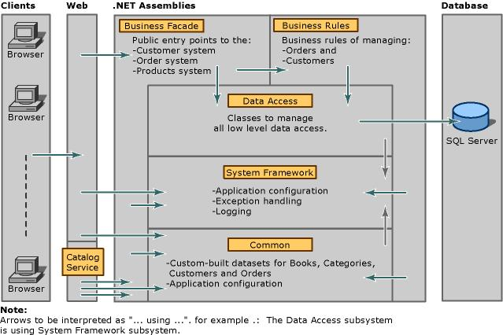

#### ADO.NET OVERVIEW

ADO.NET is an evolution of the ADO data access model that directly addresses user requirements for developing scalable applications. It was designed specifically for the web with scalability, statelessness, and XML in mind.

ADO.NET uses some ADO objects, such as the **Connection** and **Command** objects, and also introduces new objects. Key new ADO.NET objects include the **DataSet**, **DataReader**, and **DataAdapter**.

The important distinction between this evolved stage of ADO.NET and previous data architectures is that there exists an object -- the **DataSet** -- that is separate and distinct from any data stores. Because of that, the **DataSet** functions as a standalone entity. You can think of the DataSet as an always disconnected recordset that knows nothing about the source or destination of the data it contains. Inside a **DataSet**, much like in a database, there are tables, columns, relationships, constraints, views, and so forth.

A **DataAdapter** is the object that connects to the database to fill the **DataSet**. Then, it connects back to the database to update the data there, based on operations performed while the **DataSet** held the data. In the past, data processing has been primarily connection-based. Now, in an effort to make multi-tiered apps more efficient, data processing is turning to a message-based approach that revolves around chunks of information. At the center of this approach is the **DataAdapter**, which provides a bridge to retrieve and save data between a **DataSet** and its source data store. It accomplishes this by means of requests to the appropriate SQL commands made against the data store.

The XML-based **DataSet** object provides a consistent programming model that works with all models of data storage: flat, relational, and hierarchical. It does this by having no 'knowledge' of the source of its data, and by representing the data that it holds as collections and data types. No matter what the source of the data within the **DataSet** is, it is manipulated through the same set of standard APIs exposed through the **DataSet** and its subordinate objects.

While the **DataSet** has no knowledge of the source of its data, the managed provider has detailed and specific information. The role of the managed provider is to connect, fill, and persist the **DataSet** to and from data stores. The OLE DB and SQL Server .NET Data Providers (System.Data.OleDb and System.Data.SqlClient) that are part of the .Net Framework provide four basic objects: the **Command**, **Connection**, **DataReader** and **DataAdapter**. In the remaining sections of this document, we'll walk through each part of the **DataSet** and the OLE DB/SQL Server .NET Data Providers explaining what they are, and how to program against them.

The following sections will introduce you to some objects that have evolved, and some that are new. These objects are:

* **Connections**. For connection to and managing transactions against a database.
* **Commands**. For issuing SQL commands against a database.
* **DataReaders**. For reading a forward-only stream of data records from a SQL Server data source.
* **DataSets**. For storing, Remoting and programming against flat data, XML data and relational data.
* **DataAdapters**. For pushing data into a **DataSet**, and reconciling data against a database.

When dealing with connections to a database, there are two different options: SQL Server .NET Data Provider (System.Data.SqlClient) and OLE DB .NET Data Provider (System.Data.OleDb). In these samples we will use the SQL Server .NET Data Provider. These are written to talk directly to Microsoft SQL Server. The OLE DB .NET Data Provider is used to talk to any OLE DB provider (as it uses OLE DB underneath).

**Connections:**

Connections are used to 'talk to' databases, and are represented by provider-specific classes such as **SqlConnection**. Commands travel over connections and resultsets are returned in the form of streams which can be read by a **DataReader** object, or pushed into a **DataSet** object.

**Commands:**

Commands contain the information that is submitted to a database, and are represented by provider-specific classes such as **SqlCommand**. A command can be a stored procedure call, an UPDATE statement, or a statement that returns results. You can also use input and output parameters, and return values as part of your command syntax. The example below shows how to issue an INSERT statement against the **Northwind** database.

**DataReaders:**

The **DataReader** object is somewhat synonymous with a read-only/forward-only cursor over data. The **DataReader** API supports flat as well as hierarchical data. A **DataReader** object is returned after executing a command against a database. The format of the returned **DataReader** object is different from a recordset. For example, you might use the **DataReader** to show the results of a search list in a web page.

**DATASETS AND DATAADAPTERS:**

**DataSets**  
The **DataSet** object is similar to the ADO **Recordset** object, but more powerful, and with one other important distinction: the **DataSet** is always disconnected. The **DataSet** object represents a cache of data, with database-like structures such as tables, columns, relationships, and constraints. However, though a **DataSet** can and does behave much like a database, it is important to remember that **DataSet** objects do not interact directly with databases, or other source data. This allows the developer to work with a programming model that is always consistent, regardless of where the source data resides. Data coming from a database, an XML file, from code, or user input can all be placed into **DataSet** objects. Then, as changes are made to the **DataSet** they can be tracked and verified before updating the source data. The **GetChanges** method of the **DataSet** object actually creates a second **DatSet** that contains only the changes to the data. This **DataSet** is then used by a **DataAdapter** (or other objects) to update the original data source.

The **DataSet** has many XML characteristics, including the ability to produce and consume XML data and XML schemas. XML schemas can be used to describe schemas interchanged via WebServices. In fact, a **DataSet** with a schema can actually be compiled for type safety and statement completion.

**DATAADAPTERS (OLEDB/SQL)**

The **DataAdapter** object works as a bridge between the **DataSet** and the source data. Using the provider-specific **SqlDataAdapter** (along with its associated **SqlCommand** and **SqlConnection**) can increase overall performance when working with a Microsoft SQL Server databases. For other OLE DB-supported databases, you would use the **OleDbDataAdapter** object and its associated **OleDbCommand** and **OleDbConnection** objects.

The **DataAdapter** object uses commands to update the data source after changes have been made to the **DataSet**. Using the **Fill** method of the **DataAdapter** calls the SELECT command; using the **Update** method calls the INSERT, UPDATE or DELETE command for each changed row. You can explicitly set these commands in order to control the statements used at runtime to resolve changes, including the use of stored procedures. For ad-hoc scenarios, a **CommandBuilder** object can generate these at run-time based upon a select statement. However, this run-time generation requires an extra round-trip to the server in order to gather required metadata, so explicitly providing the INSERT, UPDATE, and DELETE commands at design time will result in better run-time performance.

1. ADO.NET is the next evolution of ADO for the .Net Framework.
2. ADO.NET was created with n-Tier, statelessness and XML in the forefront. Two new objects, the **DataSet** and **DataAdapter**, are provided for these scenarios.
3. ADO.NET can be used to get data from a stream, or to store data in a cache for updates.
4. There is a lot more information about ADO.NET in the documentation.
5. Remember, you can execute a command directly against the database in order to do inserts, updates, and deletes. You don't need to first put data into a **DataSet** in order to insert, update, or delete it.
6. Also, you can use a **DataSet** to bind to the data, move through the data, and navigate data relationships

**SQL SERVER**

A database management, or DBMS, gives the user access to their data and helps them transform the data into information. Such database management systems include dBase, paradox, IMS, SQL Server and SQL Server. These systems allow users to create, update and extract information from their database.

A database is a structured collection of data. Data refers to the characteristics of people, things and events. SQL Server stores each data item in its own fields. In SQL Server, the fields relating to a particular person, thing or event are bundled together to form a single complete unit of data, called a record (it can also be referred to as raw or an occurrence). Each record is made up of a number of fields. No two fields in a record can have the same field name.

During an SQL Server Database design project, the analysis of your business needs identifies all the fields or attributes of interest. If your business needs change over time, you define any additional fields or change the definition of existing fields.

**SQL SERVER TABLES**

SQL Server stores records relating to each other in a table. Different tables are created for the various groups of information. Related tables are grouped together to form a database.

**PRIMARY KEY**

Every table in SQL Server has a field or a combination of fields that uniquely identifies each record in the table. The Unique identifier is called the Primary Key, or simply the Key. The primary key provides the means to distinguish one record from all other in a table. It allows the user and the database system to identify, locate and refer to one particular record in the database.

**RELATIONAL DATABASE**

Sometimes all the information of interest to a business operation can be stored in one table. SQL Server makes it very easy to link the data in multiple tables. Matching an employee to the department in which they work is one example. This is what makes SQL Server a relational database management system, or RDBMS. It stores data in two or more tables and enables you to define relationships between the table and enables you to define relationships between the tables.

**FOREIGN KEY**

When a field is one table matches the primary key of another field is referred to as a foreign key. A foreign key is a field or a group of fields in one table whose values match those of the primary key of another table.

**REFERENTIAL INTEGRITY**

Not only does SQL Server allow you to link multiple tables, it also maintains consistency between them. Ensuring that the data among related tables is correctly matched is referred to as maintaining referential integrity.

**DATA ABSTRACTION**

A major purpose of a database system is to provide users with an abstract view of the data. This system hides certain details of how the data is stored and maintained. Data abstraction is divided into three levels.

**Physical level**: This is the lowest level of abstraction at which one describes how the data are actually stored.

**Conceptual Level**: At this level of database abstraction all the attributed and what data are actually stored is described and entries and relationship among them.

**View level**: This is the highest level of abstraction at which one describes only part of the database.

**ADVANTAGES OF RDBMS**

1. Redundancy can be avoided
2. Inconsistency can be eliminated
3. Data can be Shared
4. Standards can be enforced
5. Security restrictions can be applied
6. Integrity can be maintained
7. Conflicting requirements can be balanced
8. Data independence can be achieved.

**DISADVANTAGES OF DBMS**

A significant disadvantage of the DBMS system is cost. In addition to the cost of purchasing of developing the software, the hardware has to be upgraded to allow for the extensive programs and the workspace required for their execution and storage. While centralization reduces duplication, the lack of duplication requires that the database be adequately backed up so that in case of failure the data can be recovered.

**FEATURES OF SQL SERVER (RDBMS**)

SQL SERVER is one of the leading database management systems (DBMS) because it is the only Database that meets the uncompromising requirements of today’s most demanding information systems. From complex decision support systems (DSS) to the most rigorous online transaction processing (OLTP) application, even application that require simultaneous DSS and OLTP access to the same critical data, SQL Server leads the industry in both performance and capability

SQL SERVER is a truly portable, distributed, and open DBMS that delivers unmatched performance, continuous operation and support for every database.

SQL SERVER RDBMS is high performance fault tolerant DBMS which is specially designed for online transactions processing and for handling large database application.

SQL SERVER with transactions processing option offers two features which contribute to very high level of transaction processing throughput, which are

1. The row level lock manager

**ENTERPRISE WIDE DATA SHARING**

The unrivaled portability and connectivity of the SQL SERVER DBMS enables all the systems in the organization to be linked into a singular, integrated computing resource.

**PORTABILITY**

SQL SERVER is fully portable to more than 80 distinct hardware and operating systems platforms, including UNIX, MSDOS, OS/2, Macintosh and dozens of proprietary platforms. This portability gives complete freedom to choose the database server platform that meets the system requirements.

**OPEN SYSTEMS**

SQL SERVER offers a leading implementation of industry –standard SQL. SQL Server’s open architecture integrates SQL SERVER and non –SQL SERVER DBMS with industry’s most comprehensive collection of tools, application, and third party software products SQL Server’s Open architecture provides transparent access to data from other relational database and even non-relational database.

**DISTRIBUTED DATA SHARING**

SQL Server’s networking and distributed database capabilities to access data stored on remote server with the same ease as if the information was stored on a single local computer. A single SQL statement can access data at multiple sites. You can store data where system requirements such as performance, security or availability dictate.

**UNMATCHED PERFORMANCE**

The most advanced architecture in the industry allows the SQL SERVER DBMS to deliver unmatched performance.

**SOPHISTICATED CONCURRENCY CONTROL**

Real World applications demand access to critical data. With most database Systems application becomes “contention bound” – which performance is limited not by the CPU power or by disk I/O, but user waiting on one another for data access . SQL Server employs full, unrestricted row-level locking and contention free queries to minimize and in many cases entirely eliminates contention wait times.

**NO I/O BOTTLENECKS**

SQL Server’s fast commit groups commit and deferred write technologies dramatically reduce disk I/O bottlenecks. While some database write whole data block to disk at commit time, SQL Server commits transactions with at most sequential log file on disk at commit time, On high throughput systems, one sequential writes typically group commit multiple transactions. Data read by the transaction remains as shared memory so that other transactions may access that data without reading it again from disk. Since fast commits write all data necessary to the recovery to the log file, modified blocks are written back to the database independently of the transaction commit, when written from memory to disk.

**Chapter 6**

**SYSTEM DESIGN**

**6.1. INTRODUCTION**

Software design sits at the technical kernel of the software engineering process and is applied regardless of the development paradigm and area of application. Design is the first step in the development phase for any engineered product or system. The designer’s goal is to produce a model or representation of an entity that will later be built. Beginning, once system requirement have been specified and analyzed, system design is the first of the three technical activities -design, code and test that is required to build and verify software.

The importance can be stated with a single word “Quality”. Design is the place where quality is fostered in software development. Design provides us with representations of software that can assess for quality. Design is the only way that we can accurately translate a customer’s view into a finished software product or system. Software design serves as a foundation for all the software engineering steps that follow. Without a strong design we risk building an unstable system – one that will be difficult to test, one whose quality cannot be assessed until the last stage.

During design, progressive refinement of data structure, program structure, and procedural details are developed reviewed and documented. System design can be viewed from either technical or project management perspective. From the technical point of view, design is comprised of four activities – architectural design, data structure design, interface design and procedural design.

**6.2. NORMALIZATION**

It is a process of converting a relation to a standard form. The process is used to handle the problems that can arise due to data redundancy i.e. repetition of data in the database, maintain data integrity as well as handling problems that can arise due to insertion, updation, deletion anomalies.

Decomposing is the process of splitting relations into multiple relations to eliminate anomalies and maintain anomalies and maintain data integrity. To do this we use normal forms or rules for structuring relation.

**Insertion anomaly**: Inability to add data to the database due to absence of other data.

**Deletion anomaly**: Unintended loss of data due to deletion of other data.

**Update anomaly**: Data inconsistency resulting from data redundancy and partial update

**Normal Forms**: These are the rules for structuring relations that eliminate anomalies.

**FIRST NORMAL FORM**:

A relation is said to be in first normal form if the values in the relation are atomic for every attribute in the relation. By this we mean simply that no attribute value can be a set of values or, as it is sometimes expressed, a repeating group.

**SECOND NORMAL FORM**:

A relation is said to be in second Normal form is it is in first normal form and it should satisfy any one of the following rules.

1. Primary key is a not a composite primary key
2. No non key attributes are present
3. Every non key attribute is fully functionally dependent on full set of primary key.

**THIRD NORMAL FORM**:

A relation is said to be in third normal form if their exits no transitive dependencies.

**Transitive Dependency**: If two non key attributes depend on each other as well as on the primary key then they are said to be transitively dependent.

The above normalization principles were applied to decompose the data in multiple tables thereby making the data to be maintained in a consistent state.

**6.3. DATA DICTIONARY**

**Database Tables (Data Dictionary):** After careful analysis the system has identified to be presented with the following database tables:

** **

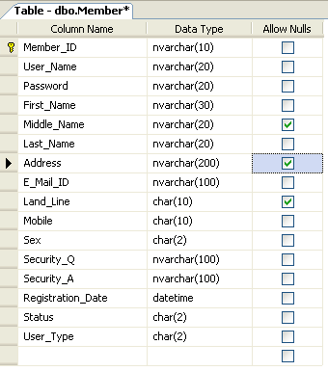









**Relation with Table Diagrams**



**6.4. E – R DIAGRAMS**

* + The relation upon the system is structure through a conceptual ER-Diagram, which not only specifics the existential entities but also the standard relations through which the system exists and the cardinalities that are necessary for the system state to continue.
  + The Entity Relationship Diagram (ERD) depicts the relationship between the data objects. The ERD is the notation that is used to conduct the date modeling activity the attributes of each data object noted is the ERD can be described resign a data object descriptions.
  + The set of primary components that are identified by the ERD are
  + Data object
  + Relationships
  + Attributes
  + Various types of indicators.

The primary purpose of the ERD is to represent data objects and their relationships.

**Entity-Relationship (E-R) Diagrams**

E-R (Entity-Relationship) Diagram is used to represents the relationship between entities in the table.

## *The symbols used in E-R diagrams are:*

SYMBOL PURPOSE

Represents entity sets.

Represents attributes.

Represents relationship set.

Line represents flow.

Structured analysis is a set of tools and techniques that the analyst.

To develop a new kind of a system: The traditional approach focuses on the cost benefit and feasibility analysis, Project management, and hardware and software selection personal considerations.



**6.5. DATA FLOW DIAGRAMS**

A data flow diagram is graphical tool used to describe and analyze movement of data through a system. These are the central tool and the basis from which the other components are developed. The transformation of data from input to output, through processed, may be described logically and independently of physical components associated with the system. These are known as the logical data flow diagrams. The physical data flow diagrams show the actual implements and movement of data between people, departments and workstations. A full description of a system actually consists of a set of data flow diagrams. Using two familiar notations Yourdon, Gane and Sarson notation develops the data flow diagrams. Each component in a DFD is labeled with a descriptive name. Process is further identified with a number that will be used for identification purpose. The development of DFD’S is done in several levels. Each process in lower level diagrams can be broken down into a more detailed DFD in the next level. The lop-level diagram is often called context diagram. It consist a single process bit, which plays vital role in studying the current system. The process in the context level diagram is exploded into other process at the first level DFD.

The idea behind the explosion of a process into more process is that understanding at one level of detail is exploded into greater detail at the next level. This is done until further explosion is necessary and an adequate amount of detail is described for analyst to understand the process.

Larry Constantine first developed the DFD as a way of expressing system requirements in a graphical from, this lead to the modular design.

A DFD is also known as a “bubble Chart” has the purpose of clarifying system requirements and identifying major transformations that will become programs in system design. So it is the starting point of the design to the lowest level of detail. A DFD consists of a series of bubbles joined by data flows in the system.

**DFD SYMBOLS:**

In the DFD, there are four symbols

1. A square defines a source(originator) or destination of system data
2. An arrow identifies data flow. It is the pipeline through which the information flows
3. A circle or a bubble represents a process that transforms incoming data flow into outgoing data flows.
4. An open rectangle is a data store, data at rest or a temporary repository of data

Process that transforms data flow

Source or Destination of data

Data flow

Data Store

**CONSTRUCTING A DFD:**

Several rules of thumb are used in drawing DFD’S:

1. Process should be named and numbered for an easy reference. Each name should be representative of the process.
2. The direction of flow is from top to bottom and from left to right. Data traditionally flow from source to the destination although they may flow back to the source. One way to indicate this is to draw long flow line back to a source. An alternative way is to repeat the source symbol as a destination. Since it is used more than once in the DFD it is marked with a short diagonal.
3. When a process is exploded into lower level details, they are numbered.
4. The names of data stores and destinations are written in capital letters. Process and dataflow names have the first letter of each work capitalized

A DFD typically shows the minimum contents of data store. Each data store should contain all the data elements that flow in and out.

Questionnaires should contain all the data elements that flow in and out. Missing interfaces redundancies and like is then accounted for often through interviews.

**SAILENT FEATURES OF DFD’S**

1. The DFD shows flow of data, not of control loops and decision are controlled considerations do not appear on a DFD.
2. The DFD does not indicate the time factor involved in any process whether the dataflow take place daily, weekly, monthly or yearly.
3. The sequence of events is not brought out on the DFD.

**TYPES OF DATA FLOW DIAGRAMS**

1. Current Physical
2. Current Logical
3. New Logical
4. New Physical

**CURRENT PHYSICAL:**

In Current Physical DFD process label include the name of people or their positions or the names of computer systems that might provide some of the overall system-processing label includes an identification of the technology used to process the data. Similarly data flows and data stores are often labels with the names of the actual physical media on which data are stored such as file folders, computer files, business forms or computer tapes.

**CURRENT LOGICAL:**

The physical aspects at the system are removed as much as possible so that the current system is reduced to its essence to the data and the processors that transform them regardless of actual physical form.

**NEW LOGICAL**:

This is exactly like a current logical model if the user were completely happy with the user were completely happy with the functionality of the current system but had problems with how it was implemented typically through the new logical model will differ from current logical model while having additional functions, absolute function removal and inefficient flows recognized.

**NEW PHYSICAL:**

The new physical represents only the physical implementation of the new system.

**RULES GOVERNING THE DFD’S**

**PROCESS**

1. No process can have only outputs.
2. No process can have only inputs. If an object has only inputs than it must be a sink.
3. A process has a verb phrase label.

**DATA STORE**

1. Data cannot move directly from one data store to another data store, a process must move data.
2. Data cannot move directly from an outside source to a data store, a process, which receives, must move data from the source and place the data into data store
3. A data store has a noun phrase label.

**SOURCE OR SINK**

The origin and /or destination of data

1. Data cannot move direly from a source to sink it must be moved by a process
2. A source and /or sink has a noun phrase land

**DATA FLOW**

1. A Data Flow has only one direction of flow between symbols. It may flow in both directions between a process and a data store to show a read before an update. The later is usually indicated however by two separate arrows since these happen at different type.
2. A join in DFD means that exactly the same data comes from any of two or more different processes data store or sink to a common location.
3. A data flow cannot go directly back to the same process it leads. There must be at least one other process that handles the data flow produce some other data flow returns the original data into the beginning process.
4. A Data flow to a data store means update (delete or change).
5. A data Flow from a data store means retrieve or use.

A data flow has a noun phrase label more than one data flow noun phrase can appear on a single arrow as long as all of the flows on the same arrow move together as one package.

**ZERO LEVEL DFD (OR) CONTEXT LEVEL DFD DIAGRAM**



**FIRST Level DFDs(SUB SYSTEM LEVEL):**

### DFD For Administrator

**Admin authentication**

**Admin Master**

**Admin Master**

**Admin Master**

**Maintain login info**

**Admin Master**

**Check Modified Details of Admin**

**Check for login Details**

### DFD For Member:

Member Master

Member Authentication

Member Master

Check for the login details.

Member Master

Maintain login info

**SECOND Level DFDs(FILE LEVEL OPERATIONS):**

### DFD For Admin operations:

Admin Master

View user details

Admin Master

Check for the races details.

Admin Master

Maintain user info

### DFD For Member operations:

Member Master

Search books

Member Master

Check for the book details.

member Master

Maintain Books info

**6.6. ACTIVITY DIAGRAMS**

A State diagram/Activity diagram is a specification of the sequences of states that an object or an interaction goes through in response to events during its life, together with its responsive action. Every state diagram is having one entry and exit state. And the state can have any number of sub-states. The above state diagram represents, how admin will interact with other objects, and how he will perform actions and change his state.



**6.7. USE CASE DIAGRAMS**

**Use Case Model**

USECASE is a description of a set of sequence of actions that a system performs that yields an observable result of value to a particular things in a model. User is an actor and these are use cases are login, view work details, assign work, approval link, view voter request details, view ward member and helper details.

**Identification of actors:**

**Actor:** Actor represents the role a user plays with respect to the system. An actor interacts with, but has no control over the use cases.

An actor is someone or something that:

* Interacts with or uses the system.
* Provides input to and receives information from the system.
* Is external to the system and has no control over the use cases.

Actors are discovered by examining:

* Who directly uses the system?
* Who is responsible for maintaining the system?
* External hardware used by the system.
* Other systems that need to interact with the system.

**Questions to identify actors:**

* Who is using the system? Or, who is affected by the system? Or, which groups need help from the system to perform a task?
* Who affects the system? Or, which user groups are needed by the system to perform its functions? These functions can be both main functions and secondary functions such as administration.
* Which external hardware or systems (if any) use the system to perform tasks?
* What problems does this application solve (that is, for whom)?
* And, finally, how do users use the system (use case)? What are they doing with the system?

**Identification of use cases:**

**Use case:** A use case can be described as a specific way of using the system from a user’s (actor’s) perspective.

SYSTEM NAME

Use case 1

Use case 2

Use case n

Actor

Actor



**6.8. SEQUENCE DIAGRAMS**

A sequence diagram is a graphical view of a scenario that shows object interaction in a time-based sequence what happens first, what happens next. Sequence diagrams establish the roles of objects and help provide essential information to determine class responsibilities and interfaces.

There are two main differences between sequence and collaboration diagrams: sequence diagrams show time-based object interaction while collaboration diagrams show how objects associate with each other.

**Object:** An object has state, behavior, and identity. The structure and behavior of similar objects are defined in their common class. Each object in a diagram indicates some instance of a class. An object that is not named is referred to as a class instance. The object icon is similar to a class icon except that the name is underlined. An object's concurrency is defined by the concurrency of its class.

**Message:** A message is the communication carried between two objects that trigger an event. A message carries information from the source focus of control to the destination focus of control. The synchronization of a message can be modified through the message specification. Synchronization means a message where the sending object pauses to wait for results.

**Link:** A link should exist between two objects, including class utilities, only if there is a relationship between their corresponding classes. The link is depicted as a straight line between objects or objects and class instances in a collaboration diagram. If an object links to itself, use the loop version of the icon.

**Admin Login Sequence:**

Managing Master Page login

m

Managing Master Page

Managing Master Admin

Managing Master Admin Home

1: Is valid

3: please check

4: Authenticated

5: Admin can view Member details, search books

And member login details

6: log out

2: operations

**Member Login Sequence:**

Managing Master Page login

Managing Master Page

Managing Master Member

Managing Master Member Home

1: Is valid

4: please check

5: Authenticated

6: Member can view details, book titles, renewal date

And search books

7: log out

3: operations

2: Enter login details

**6.9. CLASS DIAGRAMS**

**Identification of analysis classes:**

A class is a set of objects that share a common structure and common behavior (the same attributes, operations, relationships and semantics). A class is an abstraction of real-world items.

There are 4 approaches for identifying classes:

1. Noun phrase approach:
2. Common class pattern approach.
3. Use case Driven Sequence or Collaboration approach.
4. Classes , Responsibilities and collaborators Approach
5. **Noun Phrase Approach:**

The guidelines for identifying the classes:

* 1. Look for nouns and noun phrases in the use cases.
  2. Some classes are implicit or taken from general knowledge.
  3. All classes must make sense in the application domain; Avoid computer implementation classes – defer them to the design stage.
  4. Carefully choose and define the class names.

After identifying the classes we have to eliminate the following types of classes:

1. Redundant classes.
2. Adjective classes.
3. **Common class pattern approach:**

The following are the patterns for finding the candidate classes:

* 1. Concept class.
  2. Events class.
  3. Organization class
  4. Peoples class
  5. Places class
  6. Tangible things and devices class.

1. **Use case driven approach:**

We have to draw the sequence diagram or collaboration diagram. If there is need for some classes to represent some functionality then add new classes which perform those functionalities.

1. **CRC approach:**

The process consists of the following steps:

* 1. Identify classes’ responsibilities ( and identify the classes )
  2. Assign the responsibilities
  3. Identify the collaborators.

**Identification of responsibilities of each class:**

The questions that should be answered to identify the attributes and methods of a class respectively are:

1. What information about an object should we keep track of?
2. What services must a class provide?

**Identification of relationships among the classes:**

Three types of relationships among the objects are:

**Association:** How objects are associated?

**Super-sub structure:** How are objects organized into super classes and sub classes?

**Aggregation:** What is the composition of the complex classes?

**Guidelines for identifying the tentative associations:**

* A dependency between two or more classes may be an association. Association often corresponds to a verb or prepositional phrase.
* A reference from one class to another is an association. Some associations are implicit or taken from general knowledge.

**Super-sub class relationships**

Super-sub class hierarchy is a relationship between classes where one class is the parent class of another class (derived class).This is based on inheritance. This hierarchy is represented with Generalization.

**Guidelines for identifying the super-sub relationship, a generalization are**

1***.* Top-down*:*** Look for noun phrases composed of various adjectives in a class name. Avoid excessive refinement. Specialize only when the sub classes have significant behavior.

2.**Bottom-up*:*** Look for classes with similar attributes or methods. Group them by moving the common attributes and methods to an abstract class. You may have to alter the definitions a bit.

3.**Reusability*:*** Move the attributes and methods as high as possible in the hierarchy.

4**. Multiple inheritances*:*** Avoid excessive use of multiple inheritances. One way of getting benefits of multiple inheritances is to inherit from the most appropriate class and add an object of another class as an attribute

`The class diagram is core to object-oriented design.  It describes the types of objects in the system and the static relationships between them.

**Packages**

Packages allow you to break up a large number of objects into related groupings.  In many object oriented languages (such as Java), packages are used to provide scope and division to classes and interfaces.  In the UML, packages serve a similar, but broader purpose.

Package

**Classes**

The core element of the class diagram is the class.  In an object oriented system, classes are used to represent entities within the system; entities that often relate to real world objects.

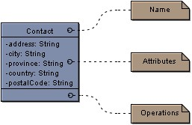

The *Contact* class above is an example of a simple class that stores location information.

Classes are divided into three sections:

**Top**: The **name**, **package** and **stereotype** are shown in the upper section of the class

**Centre**: The centre section contains the attributes of the class.

**Bottom**: In the lower section are the **operations** that can be performed on the class.

**Attributes**

An **attribute** is a property of a class.  In the example above, we are told that a *Contact* has an address, a city, a province, a country and a postal code.  It is generally understood that when implementing the class, functionality is provided to set and retrieve the information stored in attributes. The format for attributes is:

*Visibility name: type = default Value*

The visibility is as follows:

|  |  |
| --- | --- |
| **-** | Private |
| **+** | Public |
| **#** | Protected |
| **~** | Package |

In object oriented design, it is generally preferred to keep most attributes private.

**Static**: attributes that are static only exist once for all instances of the class.  In the example above, if we set *city* to be static, any time we used the *Contact* class the *city* attribute would always have the same value.

**Final:** if an attribute is declared final, it's value cannot be changed.  The attribute is a constant.

**Operations**

The **operations** listed in a class represent the functions or tasks that can be performed on the data in the class.

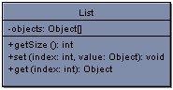

In the *List* class above, there is one attribute (a private array of Objects) and three operations.

The format for operations is:

*visibility name (parameters): type*

The format is very similar to that of the attribute except with the removal of a default value and the addition of parameters.

Parameters take the format:

*direction name: type = default value*

The direction can be one of *in*, *out*, *input* or it can be unspecified.

In Visual Case you can show and hide the parameter list for a class or all classes on a diagram.  If the list is hidden and an operation has parameters, three dots are shown (...) to indicate that parameters exist, but are hidden.  Sometimes operations have numerous parameters that need not be shown all the time.

**Generalization**

The **generalization** link is used between two classes to show that a class incorporates all of the attributes and operations of another, but adds to them in some way.

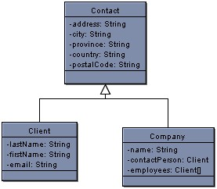

In the above diagram, we again see our *Contact* class, only now with two child classes.  We can say that *Client* and *Company* **inherit**, **generalize** or **extend** *Contact*.  In each of *Client* and *Company* all of the attributes in *Contact* (address, city, etc.) exist, but with more information added.  In the above situation *Contact* is said to be the **super class** of *Client* and *Company*.

Above, *OntarioTaxCalculator* redefines or **overrides** the implementation of the method in BasicTaxCalculator.  Essentially, the code is different but the operation is called the same way.

Sometimes you may want to force children to override methods in a parent class.  In this case you can define the methods in the super class as **abstract**.  If a class has abstract operations, the class itself is considered abstract.  Abstract methods and classes are shown in italics.  Not all of the operations in an abstract class have to be abstract.

**Interfaces**

Many object oriented programming languages do not allow for multiple inheritance.  The **interface** is used to solve the limitations posed by this.  For example, in the earlier class diagram *Client* and *Company* both generalize *Contact* but one or the other child classes may have something in common with a third class that we do not want to duplicate in multiple classes.

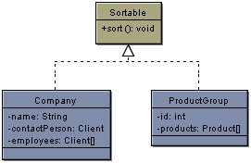

The interface *Sort able*, is used in the above example to show that both *Company* and *Product* implement the *sort* operation.  We can say that *Company* and *Product* **implement** *Sort able* or that they are *Sort able*.  Because Product already generalizes *Contact*, we could not also allow it to generalize *Sort able*.  Instead, we made *Sort able* an interface and added a **realization** link to show the implementation.

Interfaces are very similar to abstract classes with the exception that they do not have any attributes.  As well, unlike a class, all of the operations in an interface have no implementation.  The child Classes *Company* and *Product* are forced to implement the *sort* operation in its entirety.

**Associations**

Classes can also contain references to each other.  The *Company* class has two attributes that reference the Client class.

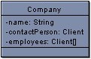

Although this is perfectly correct, it is sometimes more expressive to show the attributes as **associations**.

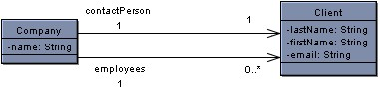

The above two associations have the same meaning as the attributes in the old version of the *Contact* class.

The first association (the top one) represents the old *contact Person* attribute.  There is one contact person in a single *Company*.  The **multiplicity** of the association is one to one meaning that for every *Company* there is one and only one *contact Person* and for each *contact Person* there is one *Company*.  In the bottom association there are zero or many employees for each company.  Multiplicities can be anything you specify.  Some examples are shown:

|  |  |
| --- | --- |
| **0** | Zero |
| **1** | One |
| **1..\*** | one or many |
| **1..2, 10..\*** | one, two or ten and above but **not** three through nine |

The arrows at the end of the associations represent their **navigability.**  In the above examples, the *Company* references *Clients*, but the *Client* class does not have any knowledge of the *Company*.  You can set the navigability on either, neither or both ends of your associations.  If there is no navigability shown then the navigability is unspecified.

**Aggregation and Composition**

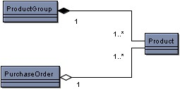

The above example shows an **aggregation** association and a **composition** association.

The **composition** association is represented by the solid diamond.  It is said that *Product Group* is **composed** of *Products*.  This means that if a *Product Group* is destroyed, the *Products* within the group are destroyed as well.

The **aggregation** association is represented by the hollow diamond.  *Purchase Order* is an **aggregate** of *Products*.  If a *Purchase Order* is destroyed, the *Products* still exist.

If you have trouble remembering the difference between composition and aggregation, just think of the alphabet.  Composition means destroy and the letters 'c' and 'd' are next to each other.

**Dependencies**

A **dependency** exists between two elements if changes to one will affect the other.  If for example, a class calls an operation in another class, then a dependency exists between the two.  If you change the operation, than the dependent class will have to change as well.  When designing your system, the goal is to minimize dependencies.

PackageDiagram

To help clarify the dependencies in your design, you may wish to draw a **Package Diagram**.  A package diagram is essentially a class diagram with only packages and dependencies showing.  Dependencies can exist between any components in the UML however at the highest level, dependencies will exist between packages.  Within a package, the dependencies may be too numerous to specify.  That is not to say that numerous dependencies are okay.  Even within a package you want to limit the dependencies, however between packages in particular you should be strict about the number of dependencies that exist.  In general, the fewer the dependencies the more **scalable** and **maintainable.**

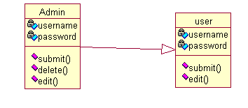

**6.10. COLLOBORATION DIAGRAM**

Admin collaboration diagram:

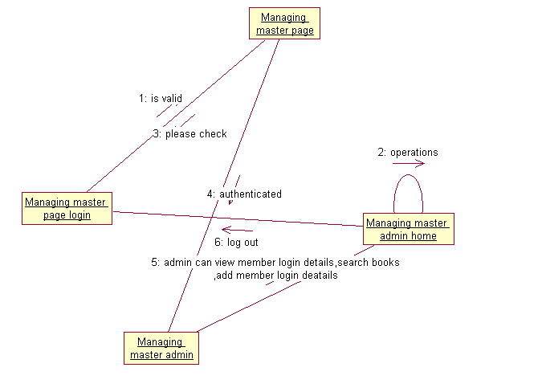

Member collaboration diagram:

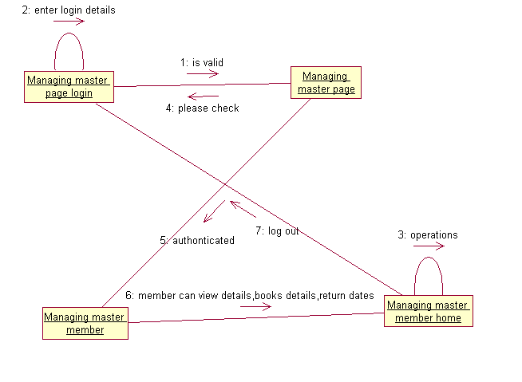

**Chapter 7**

**OUTPUT SCREENS**

**Form Design:**

Here are the following form designs for Library Managing System:

After careful analysis the system has identified to be presented with the following form design:

Login Page:

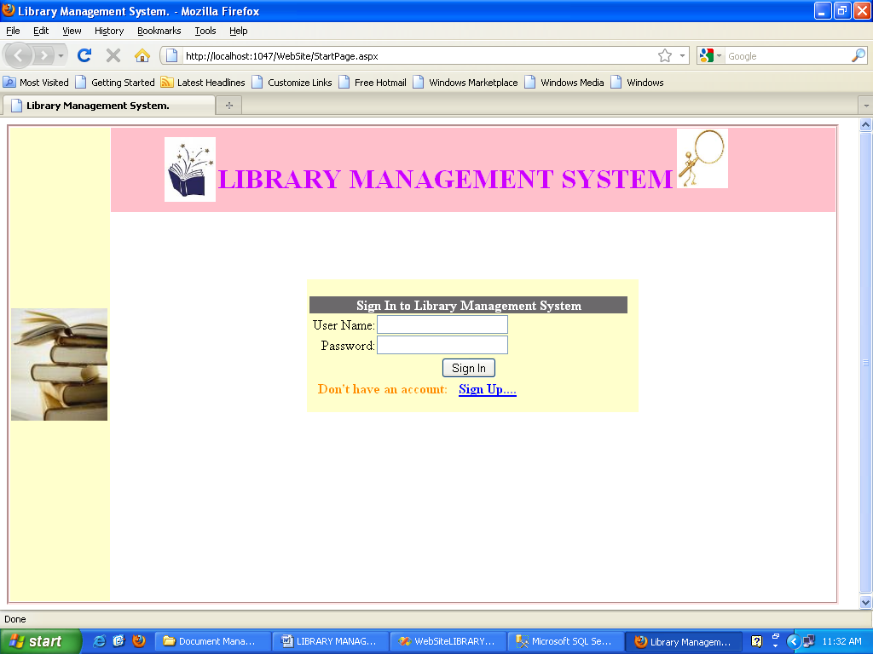

Admin Login:

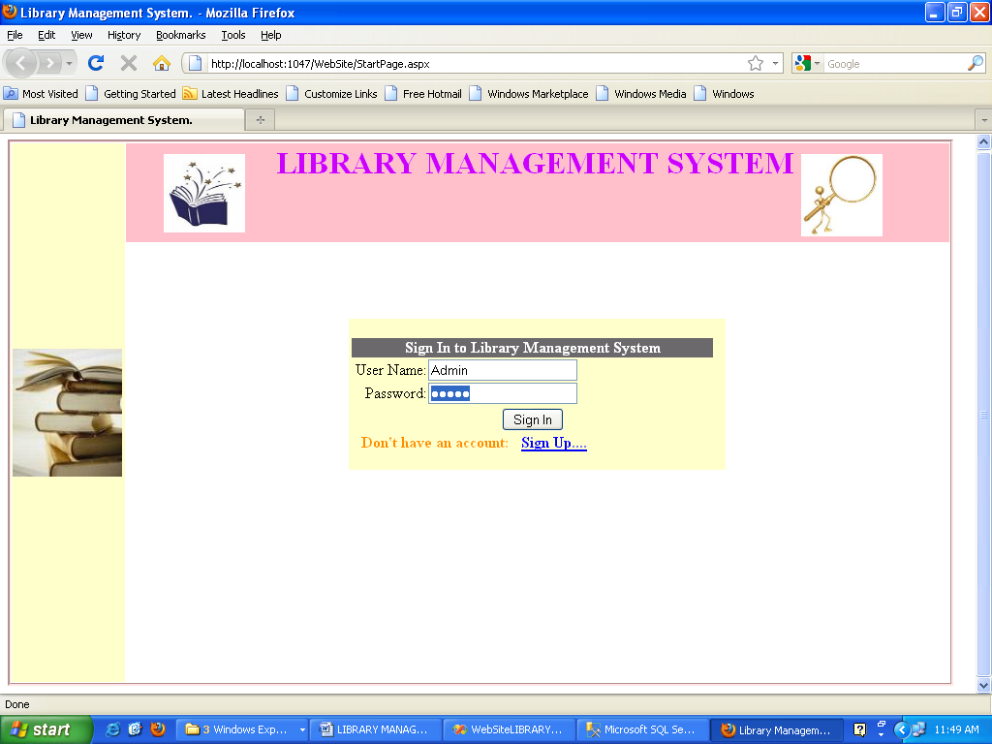

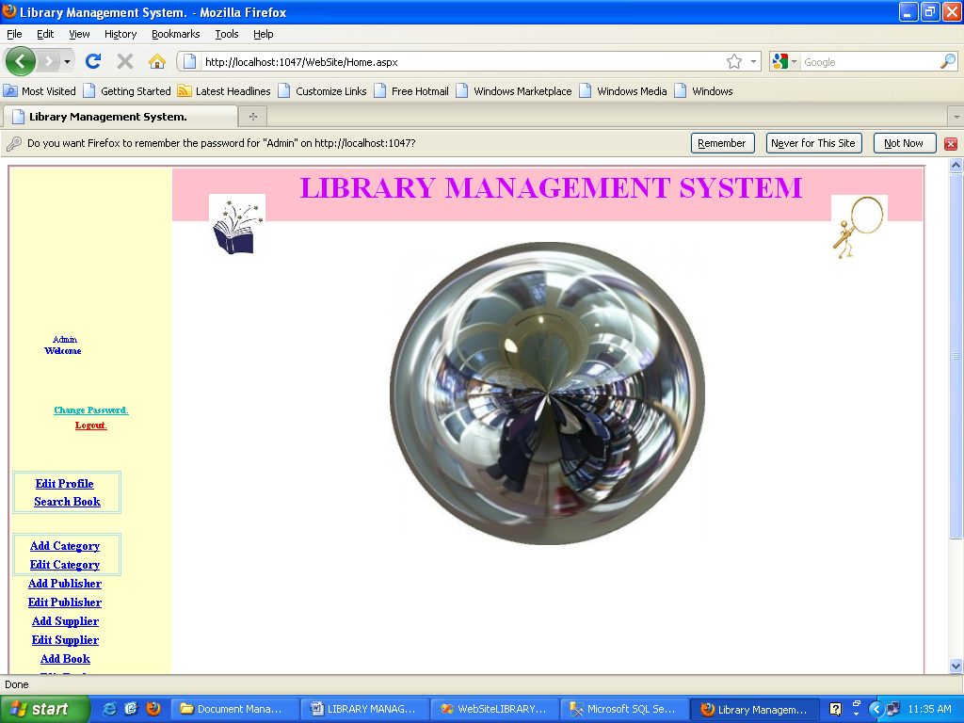

Change Password:

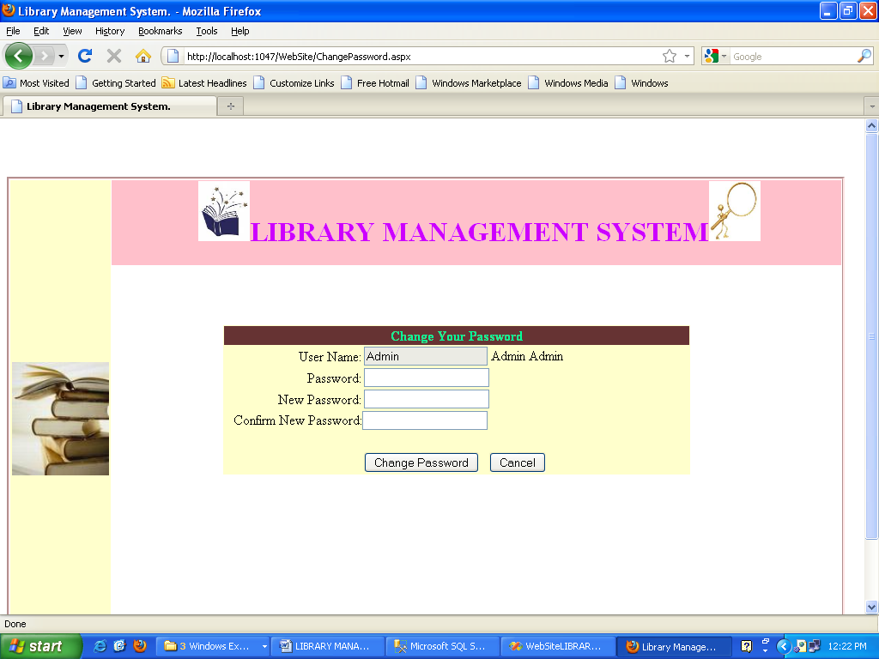

Edit Profile

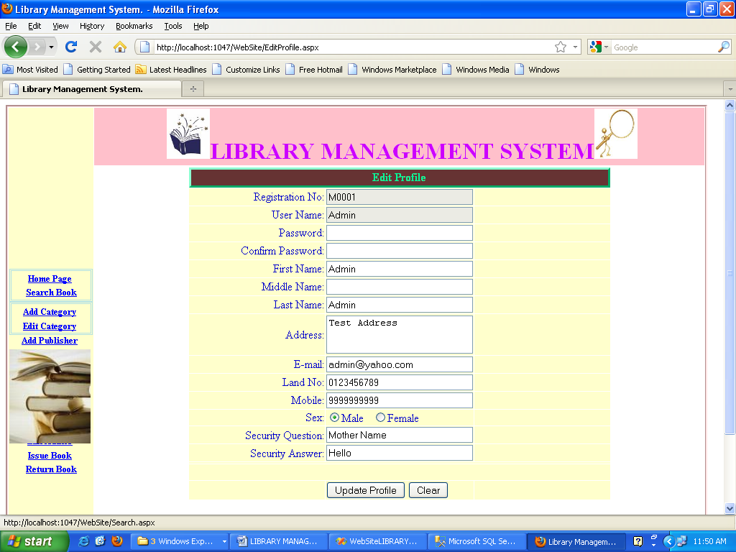

Search Books:

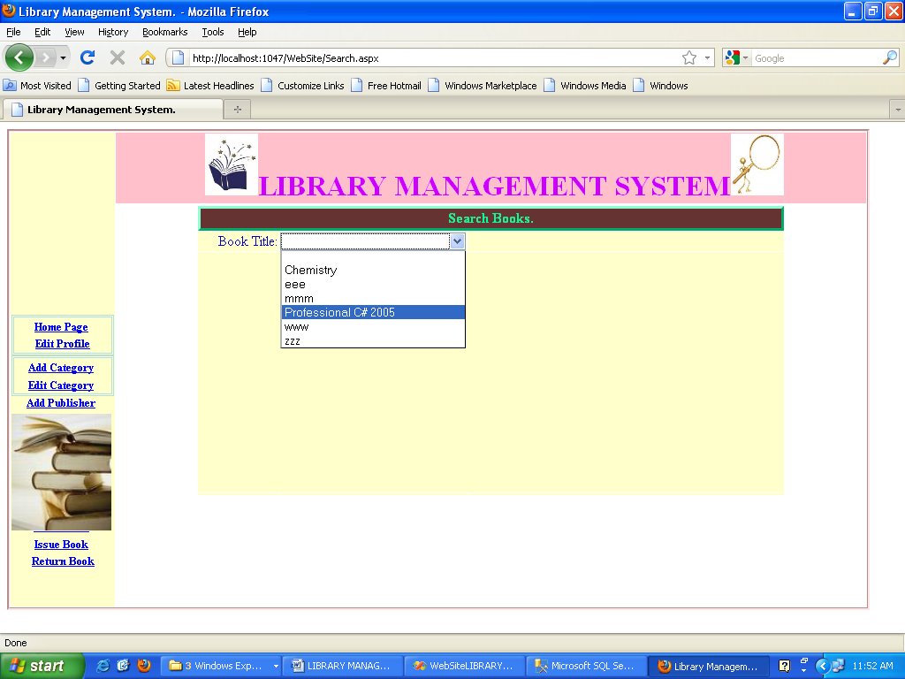

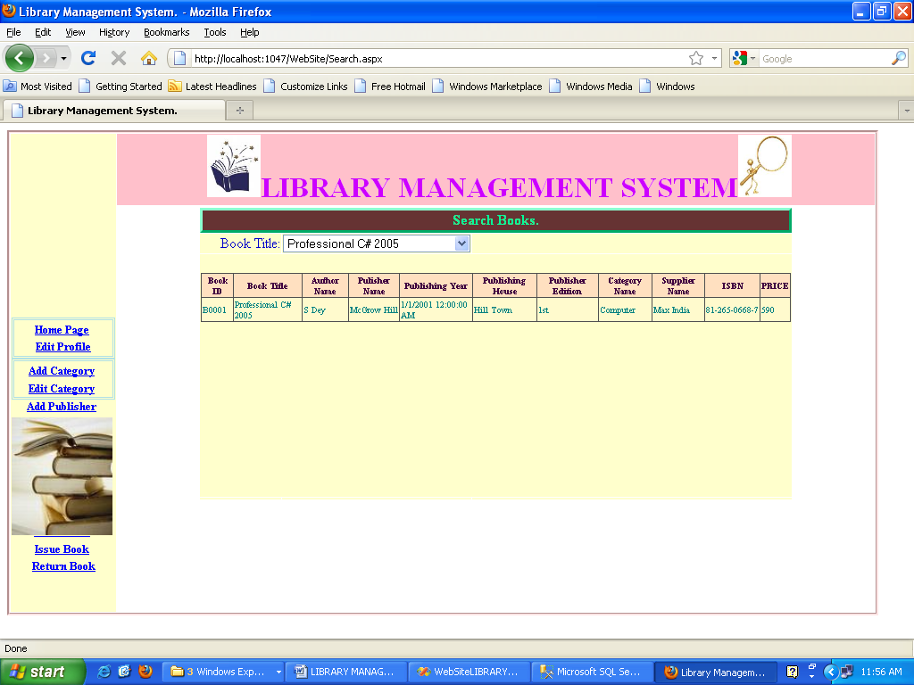

Add Category:

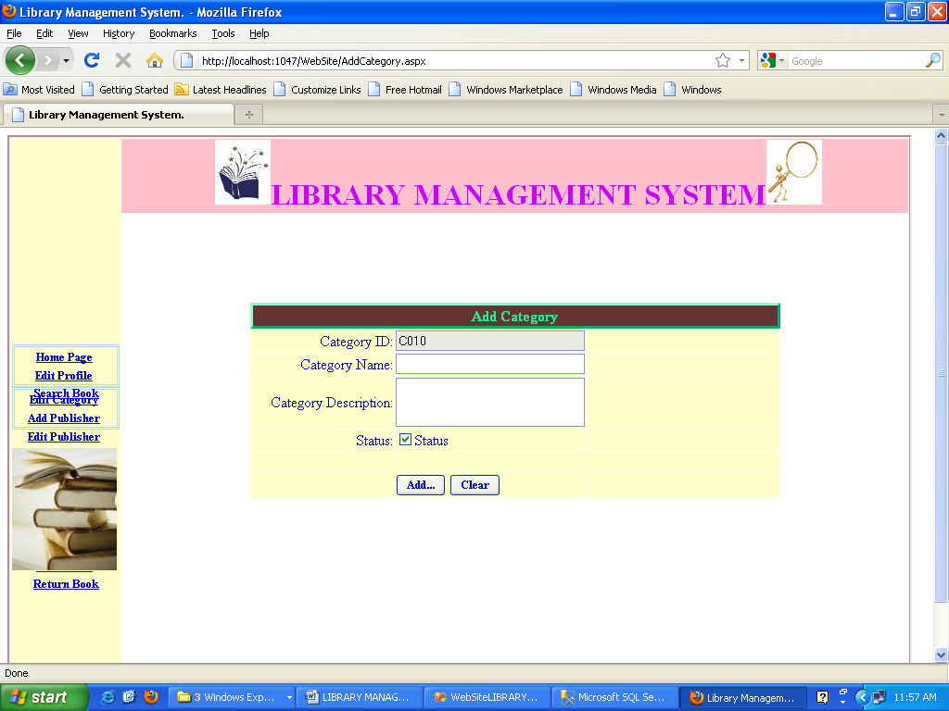

Edit Category:

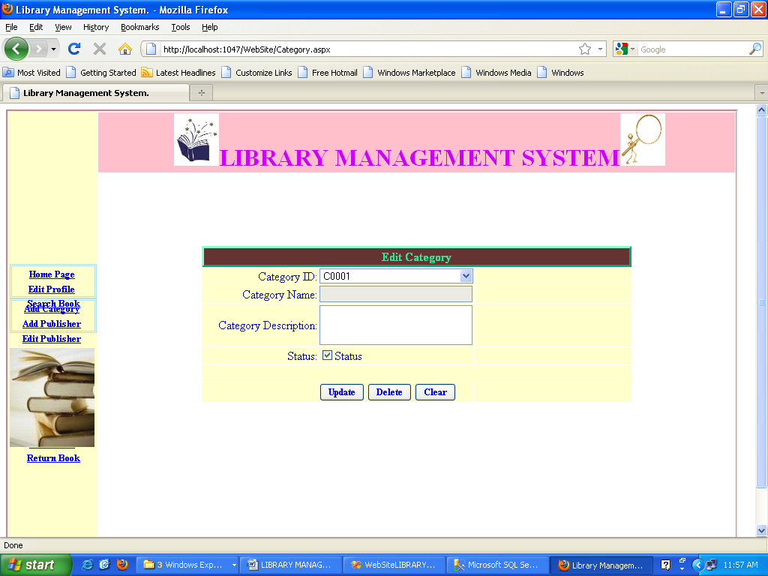

Add Publisher:

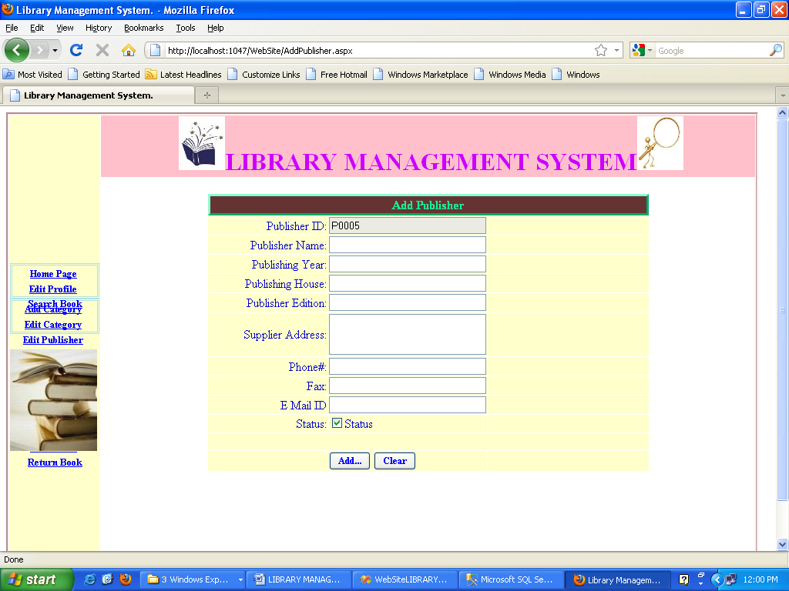

Edit Publisher:

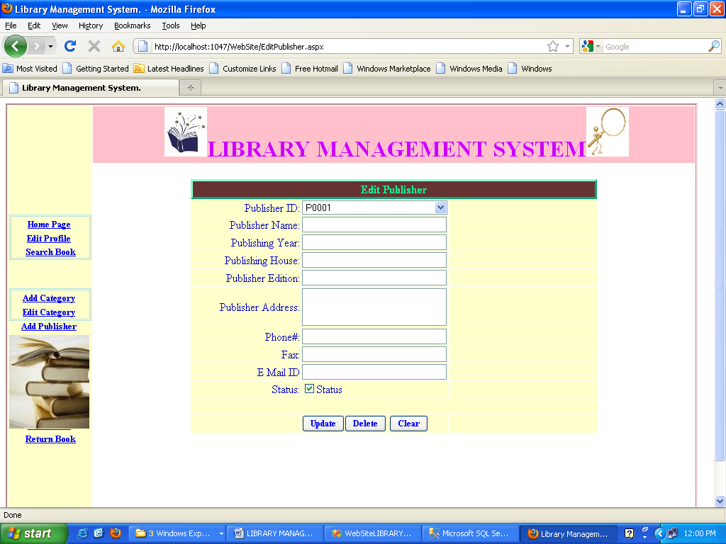

Add Supplier:

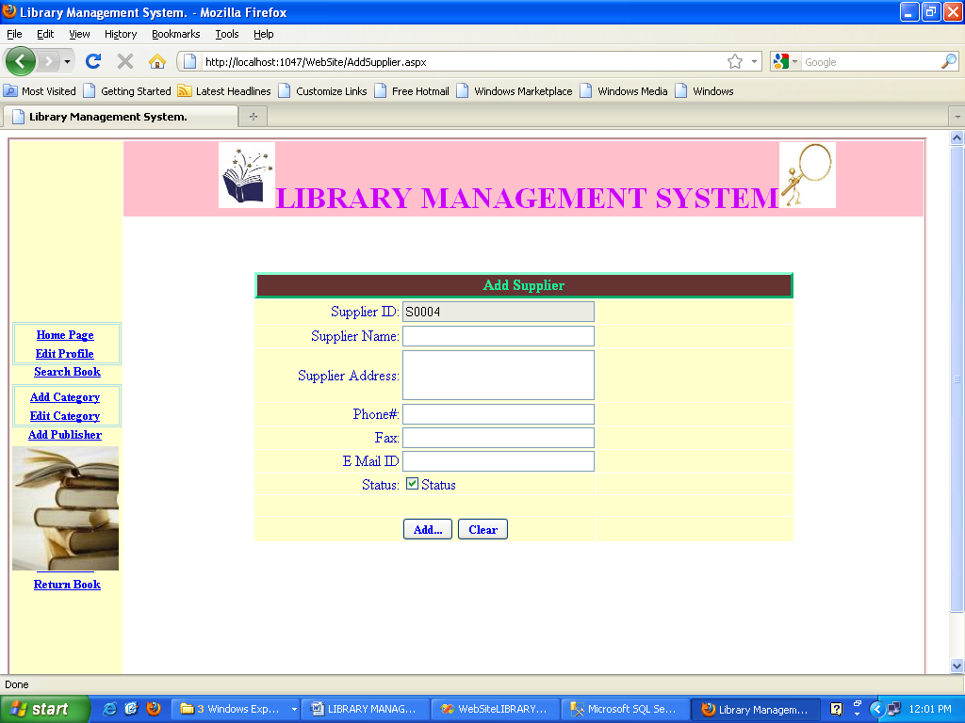

Edit Supplier:

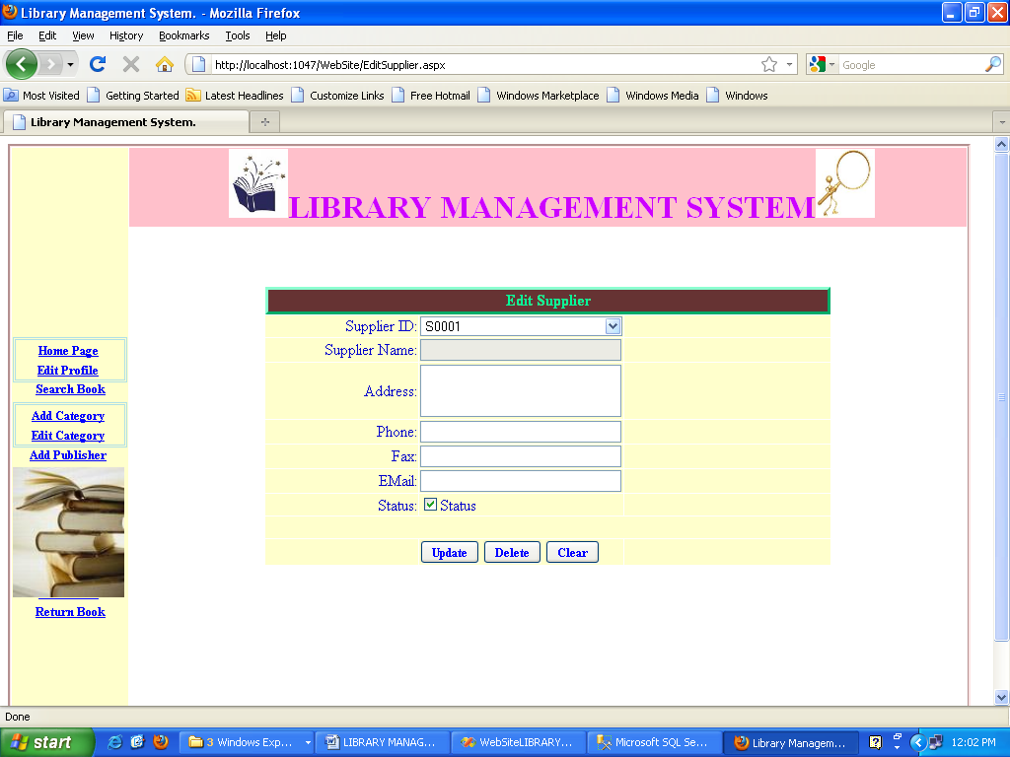

Add Author:

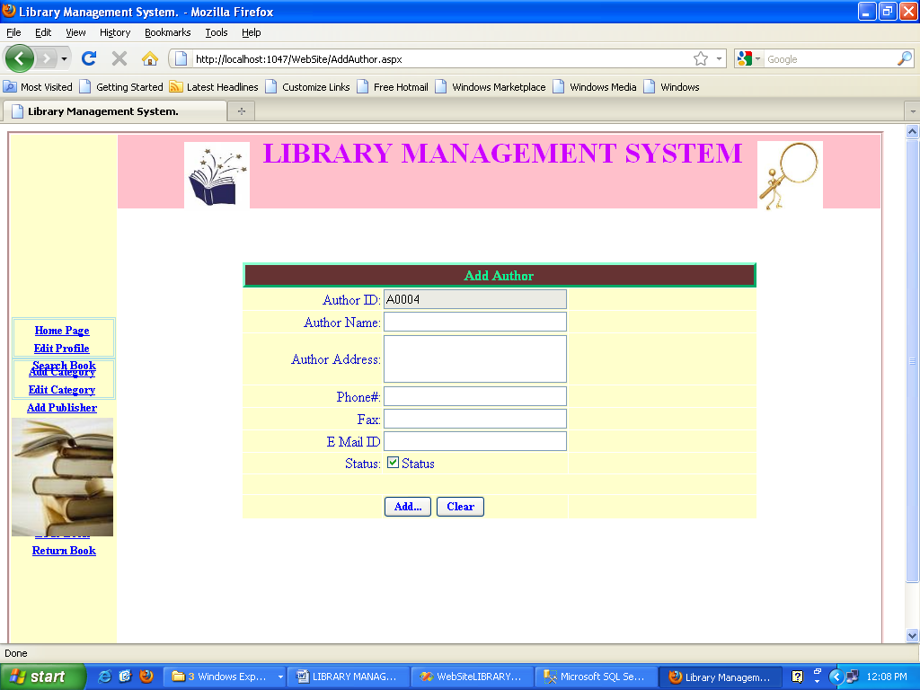

Edit Author:

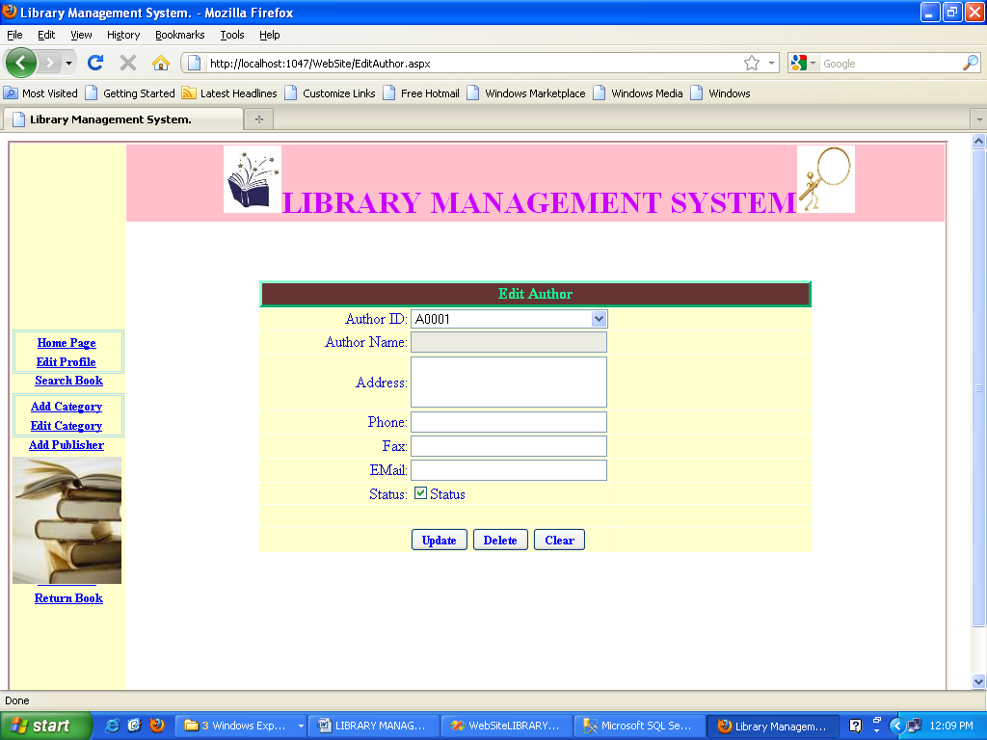

Add Book:

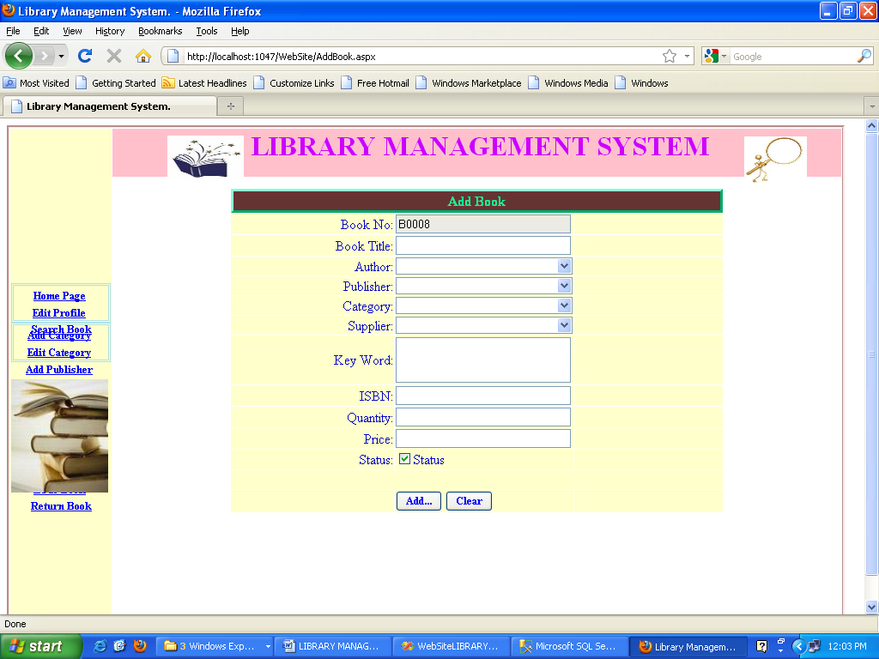

Edit Book:

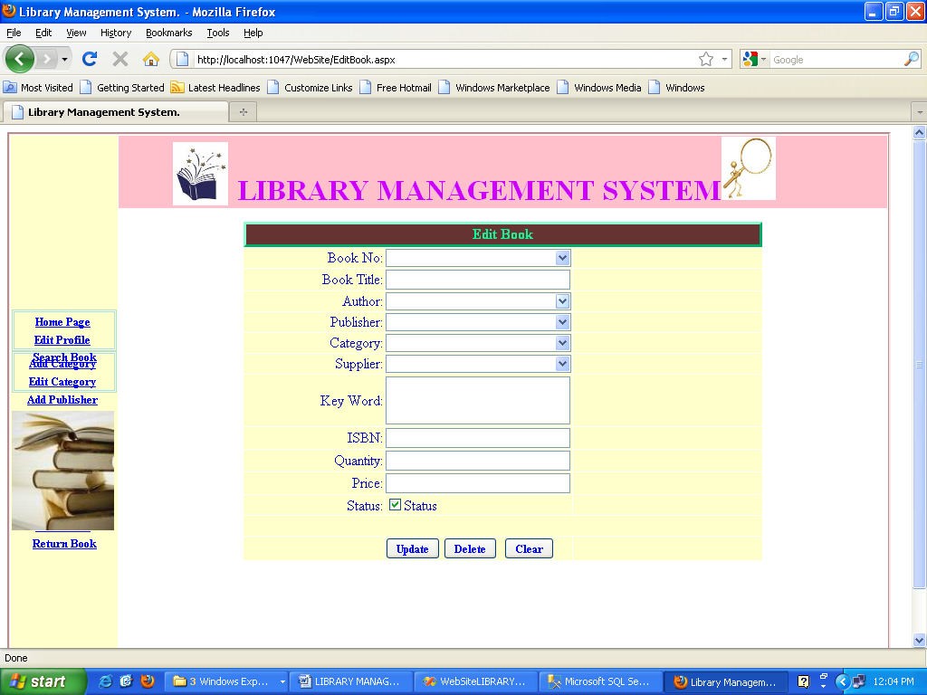

Issue Book:

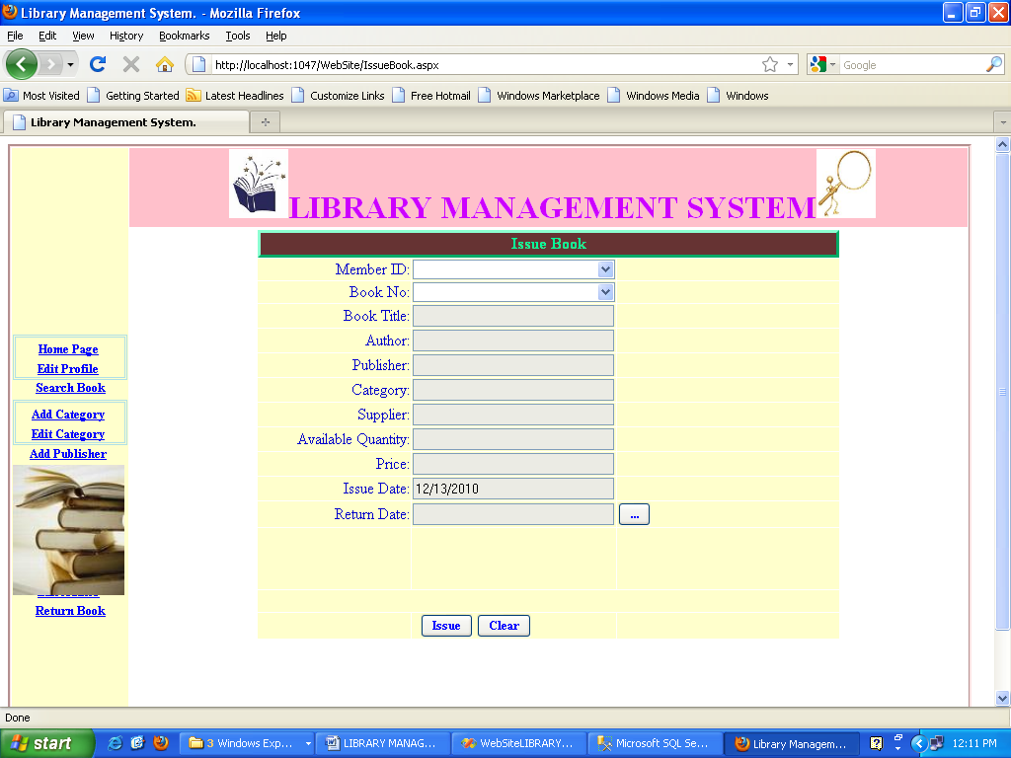

Return Book:

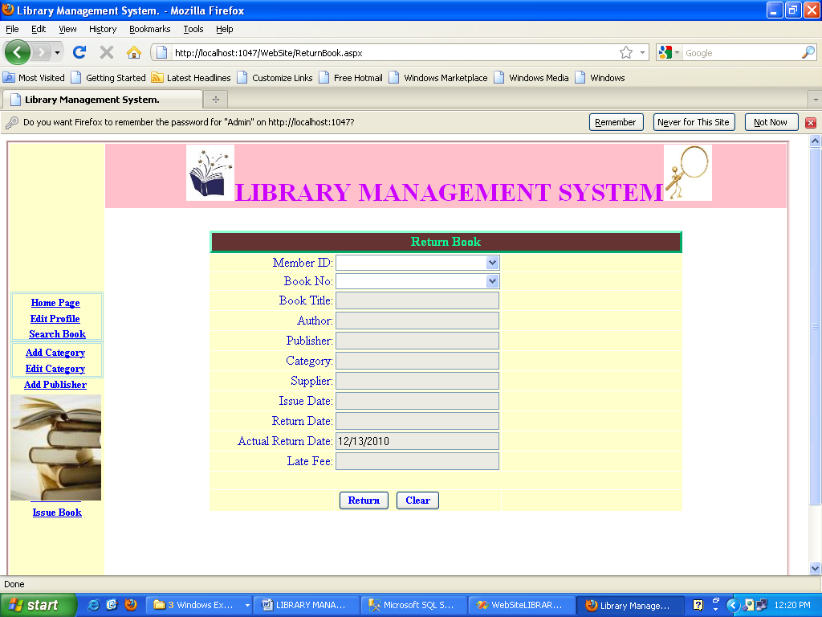

View Books:

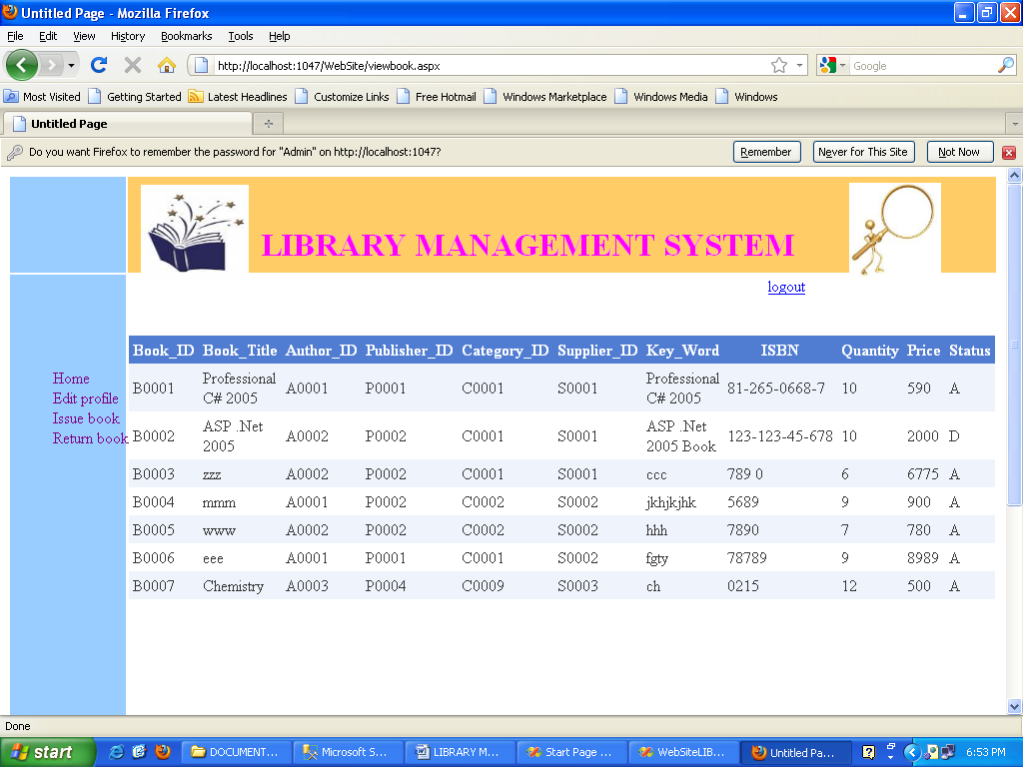

Sign Up for new Account:

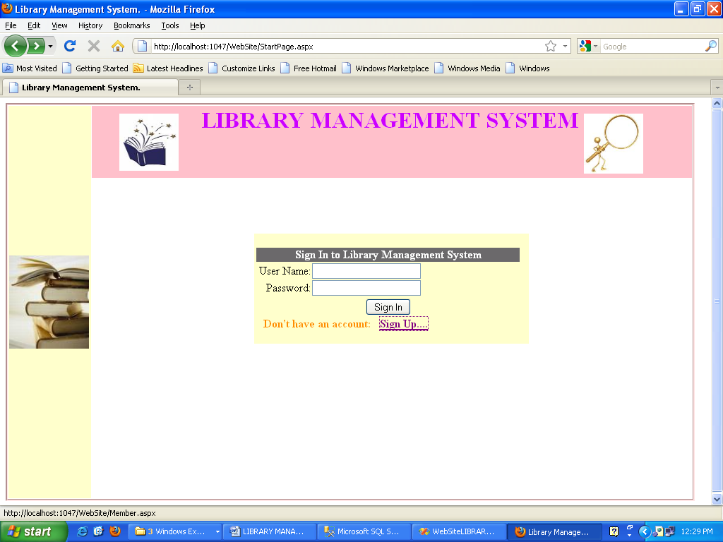

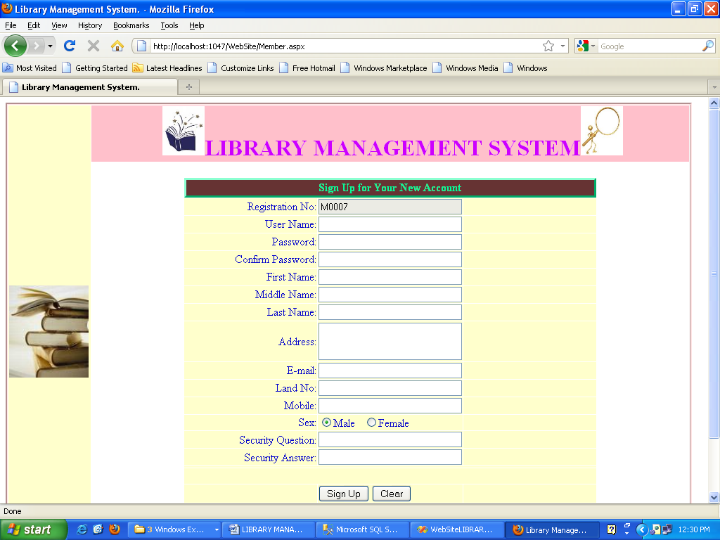

User Login:

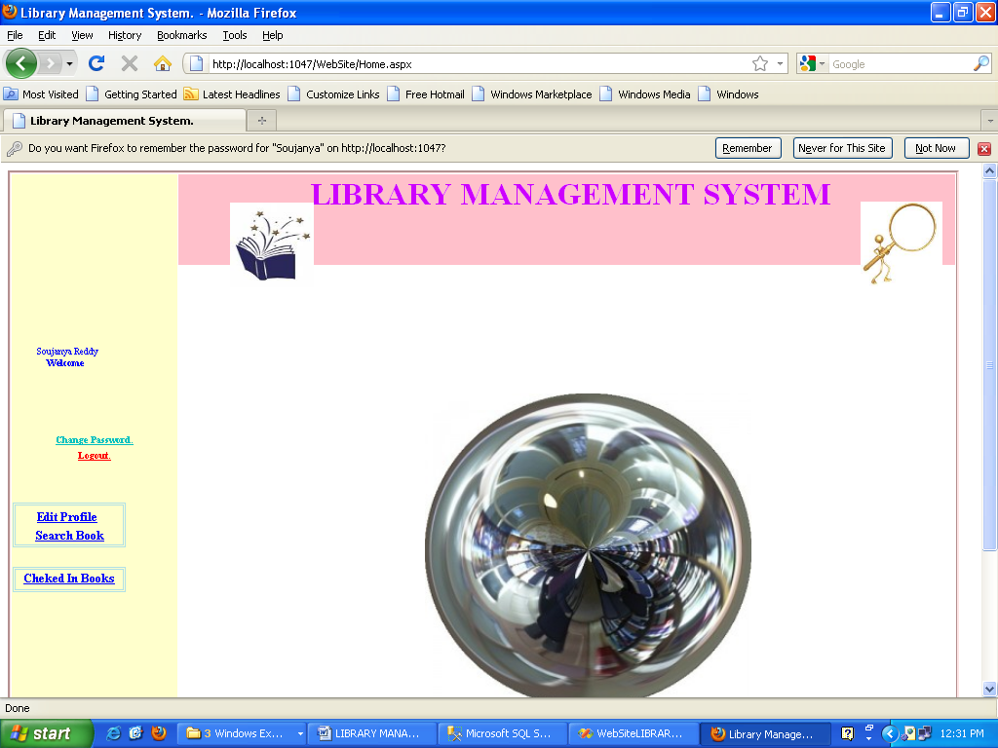

Change Password:

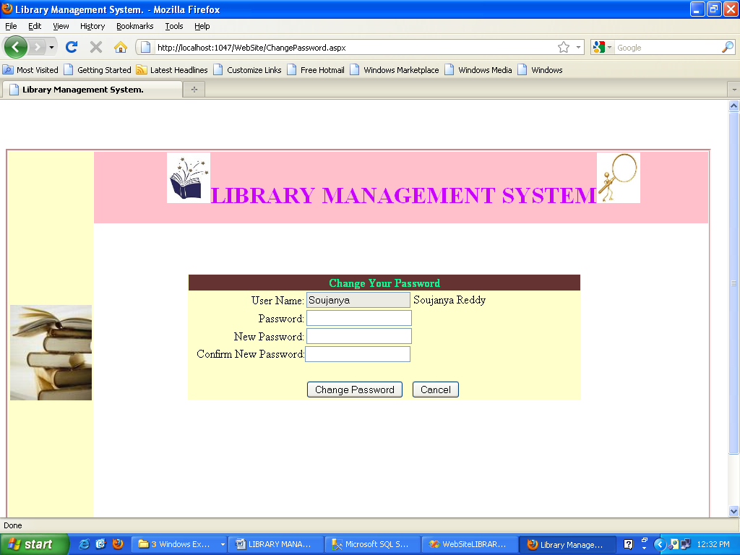

Edit Profile:

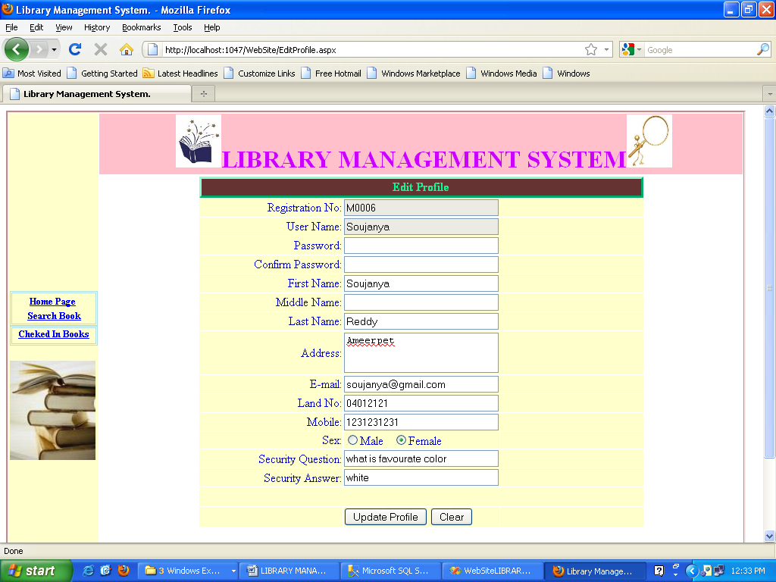

Search Books:

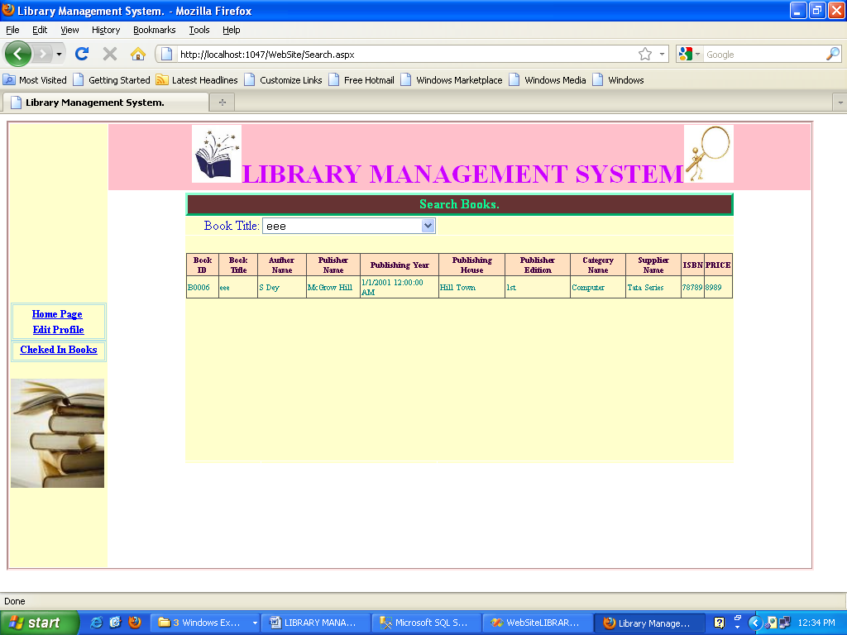

Checked in Books:

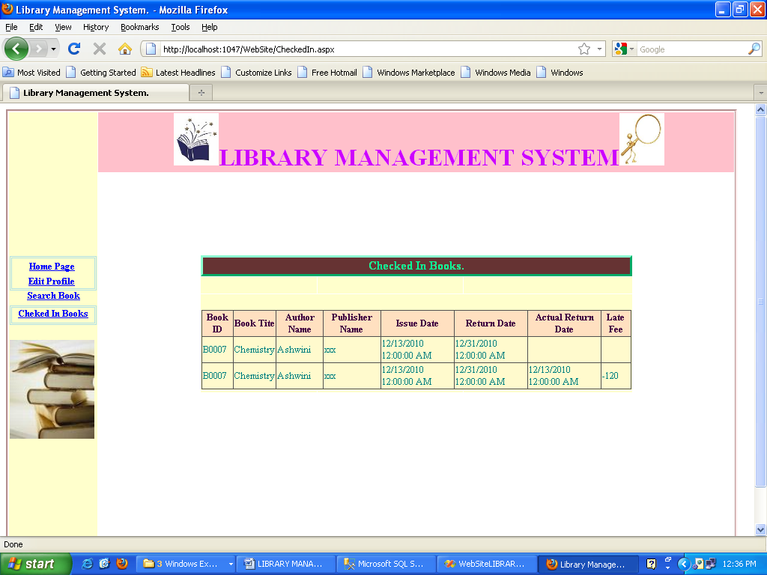

Logout:

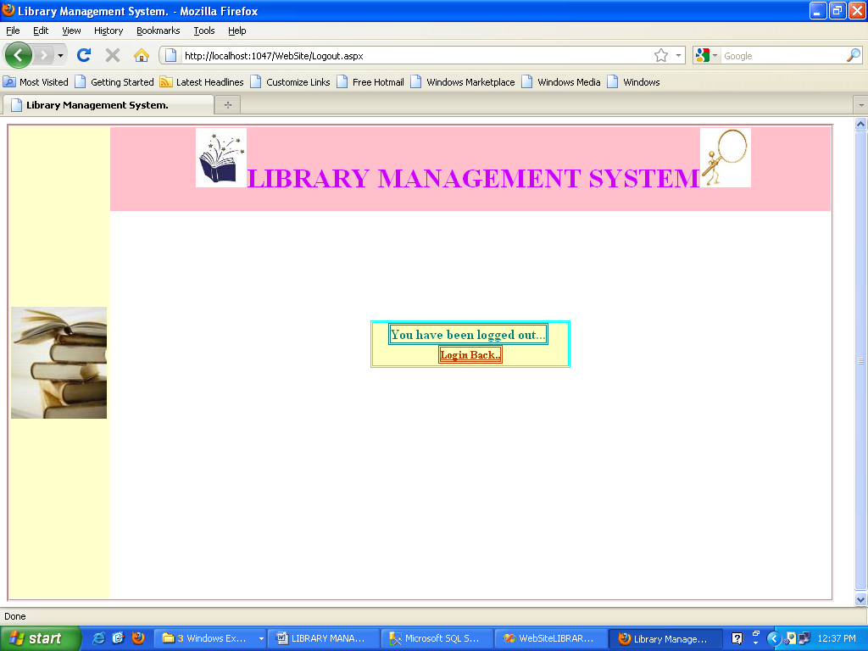

**Chapter 8**

**SYSTEM TESTING AND IMPLEMENTATION**

**8.1. INTRODUCTION**

Software testing is a critical element of software quality assurance and represents the ultimate review of specification, design and coding. In fact, testing is the one step in the software engineering process that could be viewed as destructive rather than constructive.

A strategy for software testing integrates software test case design methods into a well-planned series of steps that result in the successful construction of software. Testing is the set of activities that can be planned in advance and conducted systematically. The underlying motivation of program testing is to affirm software quality with methods that can economically and effectively apply to both strategic to both large and small-scale systems.

**8.2. STRATEGIC APPROACH TO SOFTWARE TESTING**

The software engineering process can be viewed as a spiral. Initially system engineering defines the role of software and leads to software requirement analysis where the information domain, functions, behavior, performance, constraints and validation criteria for software are established. Moving inward along the spiral, we come to design and finally to coding. To develop computer software we spiral in along streamlines that decrease the level of abstraction on each turn.

A strategy for software testing may also be viewed in the context of the spiral. Unit testing begins at the vertex of the spiral and concentrates on each unit of the software as implemented in source code. Testing progress is done by moving outward along the spiral to integration testing, where the focus is on the design and the construction of the software architecture. Talking another turn on outward on the spiral we encounter validation testing where requirements established as part of software requirements analysis are validated against the software that has been constructed. Finally we arrive at system testing, where the software and other system elements are tested as a whole.

UNIT TESTING

MODULE TESTING

SUB-SYSTEM TESING

SYSTEM TESTING

ACCEPTANCE TESTING

Component Testing

Integration Testing

User Testing

**8.3. Testing Strategies**

Testing software is a critical element of software quality assurance and represents the ultimate review of specification; and coding software testing fundamentals define the overriding objectives for software testing.

**TESTING OBJECTIVES**

* Testing is a process of executing a program with the intent of finding an error.
* A good case is one that has a high probability of finding an error.
* A successful test is one that uncovers a yet undiscovered error. If testing is conducted successfully it will uncover errors in the software. Testing cannot show the absence of defects, it can only show the software defects are present.

**TESTING PRINCIPLES**

Before applying methods to design effective test cases, a software engineer must understand the basic principles that guide e software testing.

* All tests should be traceable to customer requirements.
* Test should be planned long before testing begins.
* Testing should begin “in small” and progress towards testing “in large”
* Exhaustive testing is not possible.
* To be most effective. An independent third party should conduct testing.

**TESTING TECHNIQUES**

The primary objective for test case is to drive a set of sets that has the highest likelihood for uncovering defects in the software. Testing is the process of executing a program with the intent of finding as a yet and discovered error. To accomplish this objective tow different categories of test case technique used.

After test plan and before going to test design test case is important. According to the project requirements we have to test some conditions to ensure the quality of software. For the purpose of testing these conditions we have to write test cases.

**TESTING STRATEGIES**

Testing is a set of activities that can be planned in advance and connected systematically. A strategy for software testing must accommodate low level tests that are necessary to verify a small source code segment has been correctly implemented as well as high level tests that validate system functions against customer requirements.

**8.3.1. TEST CASE PREPARATION**

**8.3.1.1 BLACK BOX TESTING**

The concept of the black box is used to represent a system whose inside workings or no available for inspection. In a black box, the test item is treated as a “black” since its logic is unknown: all that is known is what goes in and what comes out, or the input and output. Here, in this “Electronic Management Information System” the internal functionalities have been tested.

**8.3.1.2 WHITE BOX TESTING**

White box testing assumes that the specific logic is important and must be tested to guarantee the system’s proper functioning. The main use of the white box testing is in error based testing.

It is predict on close examination of procedural detail logical providing test cases that exercise specific sets of conditions and/or loops test path enough the software. Basis path testing is a white box testing technique. The basis path method enables the test case designer to derive a logical complexity of a procedural design and use this measure as a guide for defining as basis set of execution path.

**8.3.2 TEST CASE VERIFICATION**

**8.3.2.1. UNIT TESTING**

Unit testing focuses on verifying the effort on the smallest unit of software-module. The local data structure is examined to ensure that the date stored temporarily maintains its integrity during all steps in the algorithm’s execution. Boundary conditions are tested to ensure that the module operates properly at boundaries established to limit or restrict processing.

**8.3.2.2. INTEGRATION TESTING**

Data can be tested across an interface. One module can have an inadvertent, adverse effect on the other. Integration testing is a systematic technique for constructing a program structure while conducting tests to uncover errors associated with interring.

**8.3.2.3. PERFORMANCE TESTING**

Performance Testing is used to test runtime performance of software within the context of an integrated system. Performance test are often coupled with stress testing and require both software instrumentation

**8.3.3. VALIDATION TESTING**

After performing the validation testing, the next step is output testing of the proposed system since no system would be termed as useful until it does produce the required output in the specified format. Output format is considered in two ways, the screen format and the printer format**.**

**8.3.3.1. SYSTEM TESTING**

System Testing is nothing but the testing the entire system. The following test cases are coming from the system testing.

**8.4. TEST CASES**

Test Case Report1

(Use one template for each test case)

|  |  |  |  |
| --- | --- | --- | --- |
| **GENERAL INFORMATION** | | | |
| **Test Stage:** | Unit Functionality Interface  Performance Acceptance | | |
| **Test Date:** | 09/09/2010 | **System Date, if applicable:** | 09/09/2010 |
| **Tester:** | Ramesh | **Test Case Number:** | 1 |
| **Test Case Description:** | Unit testing focuses on verifying the effort on the smallest unit of software-module. The local data structure is examined to ensure that the date stored temporarily maintains its integrity during all steps in the algorithm’s execution. Boundary conditions are tested to ensure that the module operates properly at boundaries established to limit or restrict processing. | | |
| **Results:** | Pass(OK) Fail |
| **INTRODUCTION** | | | |
| **Requirement(s) to be tested:** | Username Text field and Password Text field and the Authority Text Area. | | |
| **Roles and Responsibilities:** | Gathering the Requirements of the Project Designing and Testing. | | |
| **Set Up Procedures:** | By Installing Visual Studio. | | |
| **ENVIRONMENTAL NEEDS** | | | |
| **Hardware:** | PC with Minimum 20GB Hard Disk and 1GB RAM. | | |
| **Software:** | Windows XP/2000, MS SQL SERVER 2005/2008, MS VISUAL STUDIO 2008/2010. | | |
| **TEST** | | | |
| **Test Items and Features:** | Username and Password. | | |
| **Procedural Steps:** | If the User enters the correct username and password it will be redirected to another appropriate page so that we can confirm test is accepted. | | |
| **Expected Results of Case:** | If the page is redirected we can confirm the result of this Test case is succeeded. | | |

Test Case Report2

(Use one template for each test case)

|  |  |  |  |
| --- | --- | --- | --- |
| **GENERAL INFORMATION** | | | |
| **Test Stage:** | Unit Functionality Interface  Performance Acceptance | | |
| **Test Date:** | 09/09/2010 | **System Date, if applicable:** | 09/09/2010 |
| **Tester:** | RAMESH | **Test Case Number:** | 2 |
| **Test Case Description:** | Unit testing focuses on verifying the effort on the smallest unit of software-module. The local data structure is examined to ensure that the date stored temporarily maintains its integrity during all steps in the algorithm’s execution. Boundary conditions are tested to ensure that the module operates properly at boundaries established to limit or restrict processing. | | |
| **Results:** | Pass(OK) Fail |
| **INTRODUCTION** | | | |
| **Requirement(s) to be tested:** | After Admin login to the site, Admin can view user details, Book titles, Publisher details and view, search, Editing ,add new users and Publishers | | |
| **Roles and Responsibilities:** | Gathering the Requirements of the Project Designing and Testing. | | |
| **Set Up Procedures:** | By Installing Visual Studio. | | |
| **ENVIRONMENTAL NEEDS** | | | |
| **Hardware:** | PC with Minimum 20GB Hard Disk and 1GB RAM. | | |
| **Software:** | Windows XP/2000, MS SQL SERVER 2005/2008, MS VISUAL STUDIO 2008/2010. Windows XP/2000, MS SQL SERVER 2005/2008, MS VISUAL STUDIO 2008/2010. | | |
| **TEST** | | | |
| **Test Items and Features:** | After Admin login to the site, Admin can view user details, Book titles, Publisher details and view, search, Editing ,add new users and Publishers. | | |
| **Procedural Steps:** | The member view details about book titles, searching new books and Editing his/her details. | | |
| **Expected Results of Case:** | If the page is redirected we can confirm the result of this Test case is succeeded. | | |

**Chapter 9**

**System Security**

# 9.1. Introduction

The protection of computer based resources that includes hardware, software, data, procedures and people against unauthorized use or natural

Disaster is known as System Security.

System Security can be divided into four related issues:

* Security
* Integrity
* Privacy
* Confidentiality

**SYSTEM SECURITY** refers to the technical innovations and procedures applied to the hardware and operation systems to protect against deliberate or accidental damage from a defined threat.

**DATA SECURITY** is the protection of data from loss, disclosure, modification and destruction.

**SYSTEM INTEGRITY** refers to the power functioning of hardware and programs, appropriate physical security and safety against external threats such as eavesdropping and wiretapping.

**PRIVACY** defines the rights of the user or organizations to determine what information they are willing to share with or accept from others and how the organization can be protected against unwelcome, unfair or excessive dissemination of information about it.

**CONFIDENTIALITY** is a special status given to sensitive information in a database to minimize the possible invasion of privacy. It is an attribute of information that characterizes its need for protection.

## 9.2. SECURITY IN SOFTWARE

System security refers to various validations on data in form of checks and controls to avoid the system from failing. It is always important to ensure that only valid data is entered and only valid operations are performed on the system. The system employees two types of checks and controls:

**CLIENT SIDE VALIDATION**

Various client side validations are used to ensure on the client side that only valid data is entered. Client side validation saves server time and load to handle invalid data. Some checks imposed are:

* JavaScript in used to ensure those required fields are filled with suitable data only. Maximum lengths of the fields of the forms are appropriately defined.
* Forms cannot be submitted without filling up the mandatory data so that manual mistakes of submitting empty fields that are mandatory can be sorted out at the client side to save the server time and load.
* Tab-indexes are set according to the need and taking into account the ease of user while working with the system.

**SERVER SIDE VALIDATION**

Some checks cannot be applied at client side. Server side checks are necessary to save the system from failing and intimating the user that some invalid operation has been performed or the performed operation is restricted. Some of the server side checks imposed is:

* Server side constraint has been imposed to check for the validity of primary key and foreign key. A primary key value cannot be duplicated. Any attempt to duplicate the primary value results into a message intimating the user about those values through the forms using foreign key can be updated only of the existing foreign key values.
* User is intimating through appropriate messages about the successful operations or exceptions occurring at server side.
* Various Access Control Mechanisms have been built so that one user may not agitate upon another. Access permissions to various types of users are controlled according to the organizational structure. Only permitted users can log on to the system and can have access according to their category. User- name, passwords and permissions are controlled o the server side.
* Using server side validation, constraints on several restricted operations are imposed.

**Chapter 10**

CONCLUSION

It has been a great pleasure for me to work on this exciting and challenging project. This project proved good for me as it provided practical knowledge of not only programming in ASP.NET and C#NET web based application and no some extent Windows Application and SQL Server, but also about all handling procedure related with **“Library Managing System”.** It also provides knowledge about the latest technology used in developing web enabled application and client server technology that will be great demand in future. This will provide better opportunities and guidance in future in developing projects independently. Every project is done to explore a new solution for a given problem in this project work user-friendly software has been developed for Project Metrics*.* It’s successfully implementation makes easy the job of the people. As oraclewill be in use for years to come, next for marinating databases. The code developed here will serve the purpose for what it has been designed. This software is useful in reducing large amount of time required to maintain and update an industry database and also manage computation programs and generate query-based reports. Facilities included in the package consist of document, s/w details and efforts estimation database maintained, Computation, monitoring and also a wide range of reports. This system is developed, keeping in mind the present requirements and process. In the future, if the need arise the software developed, can be modified and upgraded as needed. Thus the package serves as a comprehensive web based system and performs all the necessary operations erstwhile eliminating monotonous book keeping operations. During the development of this system, a vivid knowledge about the actual working of the system was gained. As a whole this project helped in going various phases of development of an existing system.

**BENEFITS:**

The project is identified by the merits of the system offered to the user. The merits of this project are as follows: -

* It’s a web-enabled project.
* This project offers user to enter the data through simple and interactive forms. This is very helpful for the client to enter the desired information through so much simplicity.
* The user is mainly more concerned about the validity of the data, whatever he is entering. There are checks on every stages of any new creation, data entry or updating so that the user cannot enter the invalid data, which can create problems at later date.
* Sometimes the user finds in the later stages of using project that he needs to update some of the information that he entered earlier. There are options for him by which he can update the records. Moreover there is restriction for his that he cannot change the primary data field. This keeps the validity of the data to longer extent.
* User is provided the option of monitoring the records he entered earlier. He can see the desired records with the variety of options provided by him.
* From every part of the project the user is provided with the links through framing so that he can go from one option of the project to other as per the requirement. This is bound to be simple and very friendly as per the user is concerned. That is, we can say that the project is user friendly which is one of the primary concerns of any good project.
* Data storage and retrieval will become faster and easier to maintain because data is stored in a systematic manner and in a single database.
* Decision making process would be greatly enhanced because of faster processing of information since data collection from information available on computer takes much less time then manual system.
* Allocating of sample results becomes much faster because at a time the user can see the records of last years.
* Easier and faster data transfer through latest technology associated with the computer and communication.
* Through these features it will increase the efficiency, accuracy and transparency,

**LIMITATIONS:**

* The size of the database increases day-by-day, increasing the load on the database back up and data maintenance activity.
* Training for simple computer operations is necessary for the users working on the system.

**Chapter 11**

FUTURE IMPROVEMENT

Library management deals with the basic needs of project monitoring. The various kinds of enhancements that can be used are as follows:

**Functional Enhancements:**

Even though we are giving monitoring for the Administrator through library management**,** Still We can provide a greater Monitoring by giving versioning history for the documents. Document versioning history is not implemented which can be an added advantage if implemented. Discussion board for the developers will be an advantage.

**Financial Enhancements:**

Even though .net is not a free source online library management is built in fewer budgets.

**Security Enhancements:**

Project was built in 3-Tier architecture which is highly secured compared to single tier. By this architecture Sql hacking is prevented and better performance assured, By the state management concepts Using sessions user is allowed to do what for he is authenticated

**Chapter 12**

BIBLIOGRAPHY

* **FOR .NET INSTALLATION**

[www.support.mircosoft.com](http://www.support.mircosoft.com)

* **FOR DEPLOYMENT AND PACKING ON SERVER**

[www.developer.com](http://www.developer.com)

[www.15seconds.com](http://www.15seconds.com)

* **FOR C#.NET.Net**

MSDN (Microsoft Development Network Library)

<http://www.microsoft.com>

* **FOR SQL**

[www.msdn.microsoft.com](http://www.msdn.microsoft.com)

* **FOR ASP.NET**

[www.msdn.microsoft.com/net/quickstart/aspplus/default.com](http://www.msdn.microsoft.com/net/quickstart/aspplus/default.com)

[www.asp.net](http://www.asp.net)

[www.fmexpense.com/quickstart/aspplus/default.com](http://www.fmexpense.com/quickstart/aspplus/default.com)

[www.asptoday.com](http://www.asptoday.com)

[www.aspfree.com](http://www.aspfree.com)

[www.4guysfromrolla.com/index.aspx](http://www.4guysfromrolla.com/index.aspx)